Welcome to Third Grade!

MEET THE TEACHER:

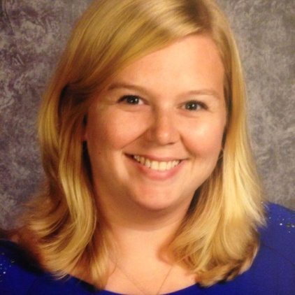
I am Mrs. Erin Margraves (Ochs) and I am really looking forward to this brand new school year. This is my fifth year teaching at MCES. I was born and raised here in Monroe and went to St. John’s for grade school. I love spending time with my family, friends, and dogs. I have a 2 year old Puggle, named Ellie, and an adopted American Bulldog/Dalmatian, named Jax. I was married at the end of June and became a step-mom to two preteens: Tommy and Anna. Your student will likely hear many stories of my “kids” and pups throughout the year. Below, I have added a chart of my favorite things so you can get to know a bit more about me. I can’t wait to get to know all of your students’ favorite things! Let’s have a great year! God Bless!

Favorite | Miss Ochs’ Answers
color | teal
pet | dog
sport | football
college | Eastern Michigan University
animal | penguin
college football team | University of Michigan!
hobbies | reading and painting

CURRICULUM: On Wednesday, August 31st at 6 p.m., St. John’s Campus will have our Curriculum Night. If you are able to join us, you will be able to experience the day of the life of your third grader! I will also provide you with a handout covering our entire curriculum for the year.

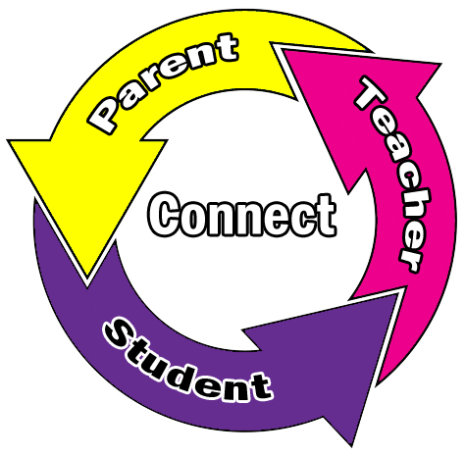
COMMUNICATION:
I will make every effort to keep you informed about our class activities and your child’s progress. If you ever have a question or concern please feel free to contact me. We will be using the following communication tools:

- Planners: The planners will list all of our day’s homework assignments. I ask that the planners be checked over and signed each night by a parent or a caregiver. Each student will document his/her behavior for the day here.
- Weekly Newsletter: Our class newsletters will be posted online every Sunday night with class information as well as dates about upcoming events and tests. I will also send home a printed copy of the newsletter on Fridays.
- Webpage: I often update our class webpage during the week to update changes in our schedule. Please try to check the school website frequently. The students may also use our webpage for access to videos and links to websites.
- Email: Please email us with any concerns.
  - Mrs. Margraves at margraves@monroecatholicschools.com
  - For Social Studies questions, please contact Mrs. Capser at capser@monroecatholicschools.com

ART, MUSIC, TECHNOLOGY & PHYSICAL EDUCATION:
These classes will be taught by teachers from the Monroe Public Schools.
I will post the schedules and teachers on our webpages as soon as I know. Their rotation will not begin until MPS begins their school year. Students will write Gym days in on their calendars and in their planners. Students will wear their gym clothes and shoes to school on PE days.

DRESS CODE: We will be following the MCES dress code found on our website. Violation forms will come home when needed.

BIRTHDAYS: As a school, we are asking that children bring in a non-edible treats for their birthday, such as pencils or stickers. Also, please note that any invitations given at school need to be sure to include everyone in our classroom, either the whole class, all boys, or all girls.

SNACK & WATER: Students are encouraged to bring a healthy snack each day. If you are willing to donate classroom peanut-free snacks for students who forget a snack, we would greatly appreciate it. Students may also keep a water bottle in their locker.

HOMEWORK: Your students will have take-home folders which need to be returned each day. There will be a calendar and homework log attached to the middle of the folder each month. Graded work will come home in a blue MCES folder on Fridays.

- Reviewing and Studying: In third grade, studying for tests or quizzes becomes important daily and helps your child become a more independent student. We will greatly be working on test-taking skills and study skills over the year. Thank you for your support in advance!

- Reading Homework: Students are expected to read for at least 15 minutes each night. This may increase after the second quarter. Each month the students will receive a new Homework Log to document that they have read. More about the Homework Log will be discussed at Curriculum Night, however, please email me any questions you may have.

- Math Homework: Each week your student will have some type of practice work, either a worksheet and/or their workbook. If no paper homework is given, please have your student practice their math facts for at least 10 minutes each night and log it on their monthly Homework Log.

WEBSITES:
- MCES Website - http://www.mcesmonroe.com/
- Our Class Page - http://www.mcesmonroe.com/ms-erin-ochs-margrave---gr-3.html

GRADES:
Grades will be posted on PowerSchool several times a month.
The MCES/AOD grading scale is as follows:
A 95-100% C 76-82%
A- 93-94% C- 74-75%
B+ 91-92% D+ 72-73%
B 87-90% D 68-71%
B- 85-86% D- 65-67%
C+ 83-84% F 0-64%

BEHAVIOR: Each student will have a small personal copy of the classroom behavior chart below. If their clip moves from the starting point (Ready to Learn), they will also move their personal clip. At the end of the day, they will record their personal behavior in their planners by color. I will also be recording their behavior as well, which will be documented for their conduct grade. As an educator, I aim to create a classroom community that is emotionally and physically safe for all children to learn and grow. Along with our charts, we will be using the school wide form to document behavior issues.
Behavior | Color Code
Outstanding | Purple
Excellent Choices | Teal
Great Effort | Blue
Ready to Learn (starting point each day) | Green
Think About It (warning) | Yellow
Make Better Choices (lose 5 minutes of recess) | Orange
Parent Contact (no recess – school wide form sent home) | Red

