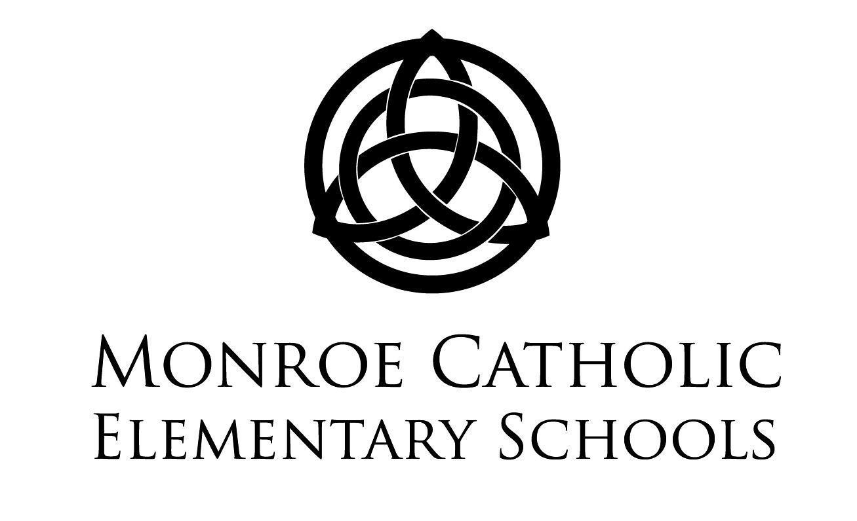

Please complete this page.
Print, and return to the school office.

I have reviewed and agree to abide by the Monroe Catholic Elementary Schools’ Parent/Student Handbook found on the www.mcesmonroe.com website and agree to abide by all policies, procedures, and expectations.

Parent/Guardian _______________________________________________________Date __________

____________________________________________________________________________________
Student Name & Grade

____________________________________________________________________________________
Student Name & Grade

____________________________________________________________________________________
Student Name & Grade

____________________________________________________________________________________
Student Name & Grade

WELCOME

Dear Families,

Monroe Catholic Elementary Schools (MCES) provides children with a well-rounded educational experience, rich in the teachings of Jesus Christ. The faculty and staff strive to create an environment of academic excellence giving each student the opportunity to develop as a whole person: spiritually, socially, physically, emotionally, and intellectually in order to meet the challenges of the future.

MCES is comprised of three Parish schools that collaborate to provide specialized education based on grade levels:
- St. Michael the Archangel: Early Elementary Campus - Infant/Toddlers to Grade 1
- St. John the Baptist: Elementary Campus – Grades 2 to 4
- St. Mary of the Immaculate Conception: Middle School Campus – Grades 5 to 8
The Articles of Agreement that founded our school collaboration can be found on the website at www.mcesmonroe.com under the History tab.

We thank you for selecting MCES for your child(ren)’s education and look forward to partnering with you to create a welcoming, stimulating, and engaging environment at all three of our campuses. Please let me know if you have any questions or concerns.
Peace,
Alicia Marting, Executive Director
(734) 241-6335

____________________________________________________________

TABLE OF CONTENTS

Parent/Student Handbook Agreement ………………………………….. 1
Welcome …………………………………… 2
Table of Contents …………………………………… 3
Mission Statement for Catholic Schools/MCES ………………………………….. 5
Expected Behavior ………………………………….. 6
Faculty and Staff ………………………………….. 6
School Advisory Committee ………………………………….. 7
Parent Teacher Organization ………………………………….. 7
Admissions ………………………………….. 7
Non-Discriminatory Policy ………………………………….. 7
Enrollment ………………………………….. 8
Registration Procedures ………………………………….. 8
Student Records ………………………………….. 9
Custodial and Non-Custodial Parents ………………………………….. 9
Health Services & Medication Policies ………………………………….. 9
Accidents ………………………………….. 9
Administration of Medication ………………………………….. 9
Emergency Medical Forms ………………………………….. 10
Illness in School ………………………………….. 10
Immunization Requirements ………………………………….. 11
Child Abuse/Neglect ………………………………….. 11
Withdrawal/Transfer ………………………………….. 12
Withdrawal ………………………………….. 12
Transfer Students ………………………………….. 12
Tuition ………………………………….. 12
Tuition Refund ………………………………….. 12
Faith and Worship ………………………………….. 12
Prayer ………………………………….. 13
Sacraments ………………………………….. 13
Curriculum ………………………………….. 13
Academic Honors ………………………………….. 13 Grading ………………………………….. 13
Homework ………………………………….. 14
Absence Due to Vacation/personal leave ………………………………….. 14
Assignments During Absences ………………………………….. 14
Intervention Assistance Team ………………………………….. 14
Parent-Teacher Conferences ………………………………….. 15
Promotion, Placement, Retention ………………………………….. 15
Report Cards ………………………………….. 15
PowerSchool ………………………………….. 15
Preschool ………………………………….. 15
Elementary K-5 ………………………………….. 16
Middle School 6-8 ………………………………….. 16
Technology ………………………………….. 16
Attendance ………………………………….. 16
Absenteeism ………………………………….. 16
Excessive Absences ………………………………….. 17
Appointments/Early Dismissal ………………………………….. 17
Tardiness ………………………………….. 17
Truancy ………………………………….. 17
Written Notice ………………………………….. 17
Athletics/Eligibility ………………………………….. 17
Eligibility (MCES) …………………………………. 18
Transfers …………………………………. 18
Student Grades …………………………………. 18
Code of Conduct ………………………………….. 19
Code of Conduct Violations ………………………………….. 19
Code of Conduct Behavior Matrix ………………………………….. 20
Bus Conduct ………………………………….. 22
Middle School Dances ………………………………….. 22
Harassment, Bullying and Abuse ………………………………….. 22
Search and Seizure ………………………………….. 22
Weapons/Explosive Materials/Pornographic Materials ………………………………….. 22
Procedures for Suspension or Expulsion ………………………………….. 23
Dress Code ………………………………….. 23
Jeans Day ………………………………….. 25
General School Information ………………………………….. 25
Birthday Celebrations ………………………………….. 25
Cell Phones ………………………………….. 25
Change of Address or Phone ………………………………….. 25
Emergency Management Guide ………………………………….. 26
Emergency Closing, Weather and Epidemics ………………………………….. 26
FERMI Emergency Plan ………………………………….. 26
Field Trips ………………………………….. 26
Fundraising ………………………………….. 26
Latchkey ………………………………….. 26
Lunch Program ………………………………….. 28
Lunchtime in the Cafeteria ………………………………….. 28
Parent Communications ………………………………….. 28
Parent Concerns ………………………………….. 29
Recess ………………………………….. 29
Visitors ………………………………….. 29
Asbestos and Radon ………………………………….. 29
Pesticides ………………………………….. 29
Code of Conduct for Volunteers (Archdiocese) ………………………………….. 29
Weapons (Archdiocese) ………………………………….. 31
Alcohol and Other Drug Use/Abuse (Vicariate of Monroe) ………………………………….. 32
Sexual, Racial, Ethnic Harassment (Archdiocese) ………………………………….. 35
Electronic Information Access/Use for Educational Purposes………………………………….. 36
Notice for Directory Information ………………………………….. 41

Right to Amend ………………………………….. 41

MISSION STATEMENT FOR CATHOLIC SCHOOLS

“Sharing Christ in and through the Church”

Through the experience of Catholic education, students will be immersed in a Catholic community which supports first and foremost their faith needs. Forming them in a holistic way so as to know Jesus, and be brought into such deep communion with Him, that they bear fruit in lifelong discipleship and witness.

Catholic Schools are:
- Inspired by a vision for holiness and sainthood
- Founded on the Christian view of the human person
- Animated by communion and community
- Imbued with Catholic world-view throughout the curriculum
- Sustained by Gospel Witness
(The Holy See’s Teaching on Catholic Schools,
Archbishop Michael J. Miller, CSB, Sophia Institute Press, pgs. 17-60)

MISSION STATEMENT FOR MCES

Monroe Catholic Elementary Schools is a Christ -centered Catholic learning community committed to the academic excellence and spiritual development of every student.

Our Catholic Schools in Monroe provide us with a rich tradition in faith-based educational excellence. The presence of Catholic schools in Monroe dates back to 1846 when the Sisters, Servants of the Immaculate Heart of Mary, came to the banks of the River Raisin to establish their religious congregation and, as their first order of business, began a school to educate the young people of our developing community.

As various ethnic populations came to this area, our city’s parishes were created. History tells us that some parishes could not afford to build schools immediately, so our different faith communities cooperated to ensure that all of their children could receive a Christ-centered education. This collaborative effort again appeared in efforts to create and sustain our Catholic secondary schools.

EXPECTED BEHAVIOR
____________________________________________________

All Students are expected to:

- Show respect to teachers and adults.
- Show respect and friendship to their peers through words and actions.
- Show respect and proper behavior when riding the bus to and from school as well as on school-related trips.
- Show respect for personal property, school/parish property, and other students’ property.
- Exhibit behavior that allows teachers to teach and students to learn.
- Obey classroom rules, routines, and procedures.
- Be present at school every day unless prevented by illness or other excusable reasons.
- Be on time every day.
- Be prepared for classes by completing assignments and having available all required learning materials.
- Be properly attired and groomed in accordance with the school’s dress code policy.
- Behave in a way that is safe to themselves and the school community.
- Visit their teacher’s classroom page to review assignments and notices, including days when school is cancelled due to weather or other issues.

- Create an environment which allows every child to maximize his/her full potential
- Update their personal pages on the school website in a timely and regular manner

All MCES parents and guardians should:

- Send their children to school on time and in correct uniform
- Communicate with the teachers and administration
- Read SchoolReach e-mails and listen to SchoolReach messages
- Check PowerSchool regularly to keep up-to-date with their student’s progress
- Check their student’s teacher webpage regularly and ensure their student is doing likewise
- Address any problems through the appropriate channels:
1. The classroom teacher
2. The Building Principal
3. The Executive Director

____________________________________________________FACULTY AND STAFF

A very dedicated and capable faculty and staff currently minister to approximately 700 children from infant (6 weeks) through eighth grade. Administrative services are provided by the Executive Director, the Pastor Delegate, currently father David Burgard and two building Principals. All teachers are duly licensed according to State of Michigan standards.

A listing of faculty and staff names and email addresses can be found at http://www.mcesmonroe.com/faculty-emails.html

___________________________________________________________________________________________

SCHOOL ADVISORY COMMITTEE

The executive director organizes, chairs, and consults with the Monroe Catholic Elementary Schools’ Advisory Committee, which acts as a consultative body to the pastors and the executive director on matters concerning MCES, assists in formulating and defining school policy, and serves as the liaison between the school and the parish communities. It is composed of members from each parish. Each pastor appoints two members from his parish as a member of the Monroe Catholic Elementary Schools’ Advisory Committee for a two year term, beginning July 1. Each Parish Education Commission will endeavor to have a representative from the Monroe Catholic Elementary Schools’ Advisory Committee and parents from each of the schools as a member(s). All pastors receive a copy of the agenda and the minutes for each meeting.

(MCES Articles of Agreement February, 2012)

Schools’ Advisory Committee Membership 2018-19
St. John the Baptist Parish
Mrs. Cheri Weakly (Current term ends June 30, 2018), Vice President
Mrs. Susan Keshen (Current term June 30, 2019)

St. Mary Parish
Mrs. JoAnn Naida (Current term ends June 30, 2020), President
Nicole Kidd (Current term ends June 30, 2019)

St. Michael the Archangel Parish
Mrs. Karen Braunlich (Term ends June 30, 2020)
Mrs. Traci Calkins (Current term June 30, 2019), Secretary

PARENT TEACHER ORGANIZATION

The MCES PTO’s mission is to strengthen our school community through the coordination of student, parent, and family-centered events, which foster healthy relationships and contribute to the academic and spiritual success of all students. (www.mcesmonroe.com)

The PTO consists of a President, Secretary, Treasurer, Hospitality Coordinator, a Campus Coordinator at each school location, and a class year representative for every class year. Committees will be formed for each activity for the planning by sending requests to the parents. Interested parents are encouraged to serve on these committees. Regular meetings will be held monthly, except during the summer months. The Parent Teacher Organization hosts both fundraising and social activities for the school. All fundraisers require the prior approval of the Executive Director.

ADMISSIONS

Non-Discriminatory Policy
Monroe Catholic Elementary Schools are committed to quality education within a Catholic environment. Consistent with this commitment, MCES has established an admissions policy which fosters family involvement in the parish.

Monroe Catholic Elementary Schools do not discriminate against students in admissions to participation in any school program or activity on the basis of race, ethnic origin, sex, or handicap which is unrelated to the student’s ability to utilize and benefit from the educational opportunities, programs and facilities offered by the school.

Students with disabilities will be evaluated for admission on an individual basis based upon their needs and the school’s ability to accommodate those needs. The final decision will be made by the building Principal.

Enrollment
Children of parish members and children of other Catholic parishes which do not have schools receive first consideration for admission. Thereafter, non-Catholic children may be admitted where there is space available, but only if their parents agree to their children’s participation in the integrated religious education program offered by the school. All students are expected to participate in all instructional programs offered by the school. Parents are expected to support and cooperate with all educational policies of the school. Parents who do not abide by the school policies or instructional programs and/or are disruptive in their actions to such may be asked to withdraw their children from the school.

Every new student will be admitted to MCES on a trial basis for one quarter. If there is consistent poor behavior, a poor attitude or inattention to academics, or disciplinary problems, the student will be asked to leave at the end of the trial period.

Students with disabilities will be evaluated for admission on an individual basis based upon their needs and the school’s ability to accommodate those needs. The final decision will be made by the building Principal.

Priority for admissions to Monroe Catholic Elementary Schools is as follows:
- Students registering for Kindergarten must be five (5) years of age by September 1 and score age appropriately on the Kindergarten Readiness Screening.
- Students registering for first grade must be six (6) years of age prior to September 1.
- Students currently enrolled
- New families who are St. John the Baptist, St. Mary, or St. Michael the Archangel parishioners
- Tenure in the parish as determined by parent date of registration in the parish

A letter of acceptance will be sent to Kindergarten families after Kindergarten screening.

The Executive Director reserves the right to limit the capacity of a classroom. Once a quota is reached, students are placed on a waiting list.

Registration Procedures
These procedures are in accordance with Section 3313.672 of Senate Bill 321, legislation dealing with missing children that became law on April 9, 1985. Section 3313.672 states:

“A pupil at the time of his/her initial entry to a public or non-public school shall present to the person in charge of admission a copy of the original certificate of his birth and copies of those records pertaining to him maintained by the school that he most recently attended. If the pupil does not present copies of the items required by this section, the principal or chief administrative officer of the school shall notify the law enforcement agency having jurisdiction in the area where the pupil resides of this and of this fact and of the possibility that the pupil may be a missing child, as this term is defined in section 2901.30 of the Revised Code.”

The Michigan Immunization Law requires “all children enrolling in any public, private, parochial or denominational school in Michigan for the first time shall submit a statement signed by a physician that they have been immunized or protected against small pox, diphtheria, tetanus, pertussis, rubella, measles, poliomyelitis, hepatitis B, and varicella (chicken pox). “ The school office provides forms for physician’s completion. No child will be admitted without this form on file. The State of Michigan also requires all children entering kindergarten to have their hearing and vision screened at least once between the ages of 3 and 5.

At the time of registration, the following items are required:
- Birth Certificate
- Baptismal Certificate (if baptized)
- Immunization Record – All children accepted into the school are required to have proper immunizations in accordance with established regulations from the State of Michigan.
- Academic and Behavioral Records, Psychological Reports, Test Results, IEP’s, Court Orders (if applicable)
- A signed Release of Records form

Student Records
A permanent record card is kept indefinitely by the school. A cumulative file of educational data for each student enrolled in the school is also maintained in the school office. The cumulative file contains: all standardized test scores, grade cards, photos, reports of all special services (i.e. speech therapy, psychological testing, IEP’s). These files are locked and are only available to certified staff members.

The parent/guardian will be given a Release of Records Form to complete and sign, indicating the name and address of the last school attended by the student. The school secretary will contact the previous school to request the transfer of student records to MCES.

Custodial and Non-custodial Parents
Monroe Catholic Elementary Schools abide by the provisions of the Buckley Amendment with respect to the rights of non-custodial parents. In the absence of a court order to the contrary, a school will provide the non-custodial parent with access to the academic records and to other school-related information regarding the child. If there is a court order specifying that there is to be no information given, or that your child is protected by a court order from seeing a non-custodial parent, it is the responsibility of the custodial parent to provide the school with an official copy of the court order. Any step-parent listed on the emergency card will be treated with the same rights and privileges as the parents of the student unless written documentation acceptable (Legally binding) to the Principal is provided. Divorced parents should provide the school with a copy of the custody section of the divorce decree. It is in the best interest of the student when families strive for mutually satisfactory pre-arrangements. Initiating discussions of issues such as financial commitment, sharing of parent letters or communications, school day visits, and extracurricular activity involvement rests with the parents.

HEALTH SERVICES & MEDICATION POLICIES

Accidents
Minor cuts and bruises will be treated in the school office. Any injury of questionable or more serious nature will be initially treated and parents will be contacted immediately. If emergency room treatment appears necessary, the school will call for an ambulance. Parents will be responsible for any costs.

Administration of Medication
The following guidelines are to be followed when it is necessary for school personnel to administer prescribed medication:
- Students are not allowed to keep medication in the classroom, locker, or to carry medication on them at any time. The only exception is an inhaler, insulin or epipen. Any child carrying an inhaler, insulin or epipen must demonstrate complete understanding of proper use and self-administration. If a student does carry an inhaler, insulin or epipen, when it is necessary for them to use it, the school office must be notified as soon as possible by the student or teacher. Routine insulin use is excluded from notifying the school office as long as a log, which includes blood sugar monitoring or accessible from an insulin pump, is kept in the classroom.
- When prescription medications and/or over-the-counter medications are to be given, a written request must be obtained from the physician and the parent/guardian before any medication can be administered by school personnel. Forms are available in the school office. Michigan law prohibits dispensing of OTC meds by all school systems without the attending physician completed paperwork.
- Medication containers must be the original container and have an affixed label including the student’s name, name of medication, dosage, route of administration and time of administration.
- New request forms must be submitted each school year and as necessary for changes in medication orders, including change of dosage.
- The medication and signed permission forms must be brought to school by the parent/guardian.
- A log will be kept in the office when a child is administered medication by school personnel.
- A parent/guardian is to pick up any unused medication once the child no longer needs to receive it or at the end of the school year. Any medication not picked up by parent/guardian will be disposed of by proper method.
- Over-the-counter medication includes any pain reliever such as: Tylenol, Motrin, ibuprofen, etc. Also included are cough drops, mouth wash, lotions or creams for rashes or irritation from insect bites, sunburns, etc. If you make a purchase to treat any symptoms, it is an over-the-counter medication. Any OTC medications required by a student must be provided by the parents.

Emergency Medical Forms
The emergency medical form is essential for medical action to be taken upon sudden need. The authorization of this form does not cover major surgery unless the medical opinions of two licensed physicians or dentists, concurring in the necessity of such surgery, are obtained prior to the performance of such surgery. The form must be on file for all registered students the first day of school every year. New students registering during the school year have one week to complete the form.

Illness in School
Should a child become ill during the school day, a parent/guardian will be asked to pick up the child. If unable to reach the parent/guardian, the authorized person on the emergency medical form will be contacted to pick up the child. In the event that the authorized person picks up the child, and the child’s immediate family has voice mail/answering machine, a notice will be left stating that the child went home with the authorized person and why. If the illness is of a life threatening nature, the emergency services will be called immediately followed by a call to the parents.

A child who exhibits the following signs of illness will be isolated in the school office and must be picked up:
- Temperature elevated to 99.5 degrees Fahrenheit or above (the child must be fever-free, diarrhea and/or vomit-free for at least 24 hours before returning to school)
- Skin rash of undetermined origin
- Diarrhea and/or vomiting
- Evidence of lice infestation
- Abdominal pain
- Has an accident and may possibly need medical attention
- Has signs or symptoms of a communicable disease including Pink Eye (Conjunctivitis)

Parents/guardians should keep a child home from school following these health guidelines:
- If a child has a runny or stuffy nose with flu-like symptoms, he or she should not come to school.
- A child should stay home for 24 hours after a fever breaks.
- If a child is sick during the night or in the morning before school, he or she should stay at home.
- If strep throat is suspected, the child must have a strep test taken to be sure that strep is not present. If strep is detected the student may return to school only with a doctor’s note.
- Children having diarrhea should be kept at home.

Children who are ill and come to school are not only subjecting the other children to illness, but are also at higher risk of catching something else since their resistance is lower.

The following are a list of the most common communicable diseases and their symptoms:
- Chicken Pox – feverish…with a rash that appears in the form of small pimples which will fill up with a clear fluid. Rash frequently begins on the trunk of the body or under arms. Incubation period is 14-21 days.
- Conjunctivitis (pink eye) – Redness and swelling of the membranes of one or both eyes with some burning and itching, sensitivity to light, and a discharge. Immediate medical treatment is needed. Exclusion from school until fully recovered.
- Head lice (pediculosis) – If your child is suspected of having head lice, he/she will be sent home immediately. Following evidence of proper treatment and that all nits have been removed, the child may return to school. The school does not routinely check children for nits/head lice. The school should be contacted immediately if you discover your child has head lice.
- Fifth’s Disease – Fever, bright red rash usually beginning on face (slap cheek) and spreads to trunk, and extremities. Normally clears in one week. Incubation period 12-14 days.
- Hand, Foot & Mouth (coxsackievirus) – Fever with a raised rash particularly on palms, soles and around the mouth that progress to blisters and scabs. May have painful sores in mouth that cause swallowing to be difficult.
- Scarlet Fever and Streptococcal (sore throat) – fever, headache, sore throat, vomiting. A fine rash appears with scarlet fever/scarlatina. Incubation period is 2-5 days. Isolation for 48 hours after the start of antibiotic treatment is suggested. Child may return to school with a note from the doctor that the child has been treated and is released to return to school. Incubation is 3-6 days.
- Ringworm (tinea) – If on scalp, may have patches of temporary baldness and hair of affected area will be brittle. If on skin will have flat ring like rash with inflammation that may itch and burn.
- Mononucleosis – Fever, sore throat with swollen glands, fatigue and possibly abdominal pain. Incubation 30-50 days.

Immunization Requirements
Pupils in preschool through grade 8 unless otherwise exempt, must be immunized against certain diseases by type of vaccine and number or required doses. The parents/guardians submit written evidence obtained from the physician that their child meets or exceeds the minimum immunization requirements, which are:

DPT (diphtheria, tetanus, pertussis) and/or Td Vaccine – dosage: 4;
Polio – dosage: 3;
MMR (Measles, Mumps, Rubella) – dosage: 2;
Hepatitis B - dosage: 3;
Varicella – dosages: must be administered on or after the 1st birthday before beginning kindergarten. A written statement from physician claiming history of disease is acceptable.

Child Abuse/Neglect
The Michigan Law (Act No. 238, Public Acts of 1975) requires that all cases of suspected child abuse and/or neglect be reported to the appropriate office of the Michigan Department of Social Services. A report will also be made to the Catholic Schools Office. State law requires school administrators, school counselors, teachers, social workers and members of the clergy, have reason to believe that a child under the age of eighteen years has been abused or neglected must report the matter promptly.

“Child abuse” is defined as harm or threatened harm to a child’s health or welfare by a parent, legal guardian, teacher, teacher’s aide, clergy, or any other person responsible for the child’s health or welfare through non-accidental, physical or mental injury, sexual abuse, sexual exploitation, or maltreatment. “Child neglect” is defined as failure to provide adequate food, clothing, shelter or medical care.

WITHDRAWAL/TRANSFER

Withdrawal
When students withdraw from Monroe Catholic Elementary Schools, they are to return all property belonging to the schools and pay any fines or charges that may be due. The parents/guardians must complete a release of records form with the receiving school before student records will be transferred. The school secretary will contact the previous school to request the transfer of student records to MCES. However, if fees and/or tuition are in arrears, grades or transcripts may be withheld until such amounts are paid in full. Health records will be forwarded to the receiving school.

Transfer Students
Students who are transferring to MCES will be admitted only after application forms and tuition arrangements are completed. Registration will not be finalized until records have been reviewed by the Principal and the parents and students have signed the Probational Acceptance Form.

TUITION

The three pastors of the Monroe Parishes and the Executive Director of MCES will set the tuition scale prior to registration for the following school year.

Students are accepted for enrollment upon receipt of:
- Payment of tuition deposit
- Completion and return of the enrollment form and Tuition Agreement
- Any past accounts paid in full

Tuition Refund
Students withdrawn from MCES after June 30 may be subject to a cancellation penalty in the amount of 25% of prepaid tuition. The refunded amount for students leaving during the school year will be given on a quarterly basis after review by the Executive Director and the Finance Director. Tuition and fees must be paid in full before academic records will be released to the parents/guardians or the receiving school. Non-payment of such charges will also be sufficient basis for refusing to award a diploma.

FAITH AND WORSHIP

Students receive 30 – 50 minutes of formal religious instruction daily. The religion curriculum is designed so that through consistent teaching, students will come to know and understand scripture and the teachings of the Catholic Church; experience a nurturing and loving Christian community; learn to serve and reach out to others in efforts toward peace and justice; and come together in prayer and worship.

Students attend weekly Mass and families are always invited to attend school liturgies. Parents are also reminded of their responsibility to make sure that their family attends weekly Mass faithfully, to provide a Christian atmosphere in the home, and to pray for their child/ren and all involved in his/her education.

Prayer
Catholic beliefs and values are integrated in all aspects of the school’s educational program. Prayers (formal and informal) are said throughout the day. All students (Catholic and Non-Catholic) are required to participate in religious instruction, prayer, liturgy, and related religious activities. Each class will integrate a service experience as part of the curriculum to foster in our children a sense of Christian responsibility and social justice.

Sacraments
Parents and teachers work in partnership with the parish’s Director of Religious Education to prepare children to receive the sacraments of First Reconciliation, First Communion, and Confirmation. MCES students receive the sacraments at their home parish. Parent involvement is mandatory prior to reception of the sacraments; First Reconciliation – gr. 2; First Communion – gr. 2; Confirmation – gr 8.

CURRICULUM

“Parents are the first and foremost educators of their children. Their role as educators is so decisive that scarcely anything can compensate for their failure in it.”
(cf. Vatican II, Education)

Parents do not relinquish their right and duty to educate, but only delegate a part of their responsibility to the school. Without the cooperation of the parents, the school cannot fully educate the child.

Michigan Association for Nonpublic Schools (MANS) is the accrediting agency for Monroe Catholic Elementary Schools. Curriculum guidelines flow from the Archdiocese of Detroit Religion Course of Study, Michigan Academic Content Standards, and National Content Standards. The Common Core Content Standards, accepted by the state of Michigan, are the minimum level of instruction and MCES works to exceed these guidelines.

Iowa Assessment and Cognitive Abilities standardized tests, which measure student strengths and identify areas for growth, are administered in October for grades 1 – 8.

The MCES teachers are fully licensed by the State of Michigan and participate in ongoing professional development. All faculty members are dedicated, caring, and committed to the ministry of Catholic education. Our fine Catholic school educators make a difference in the students’ lives by integrating learning and living a commitment of faith.

Academic Honors

First Honors: Students in grades 3 through 8 who receive a 93% or higher in:
- All academic content areas, including electives
- And all As in conduct and effort in all classes

Second Honors: Students in grades 3 through 8 who receive an 85% or higher in:
- All academic content areas, including electives
- And As and/or Bs in conduct and effort in all classes

Grading Policy
Percentage grades will be used on the grade cards for grades 3 through 8. Grading scale is as follows:
A 93% - 100% C 74% - 84% F 0% - 64%
B 85% - 92% D 65% - 73%

Homework
Homework assignments reinforce learning begun at school and allow students to practice skills. Parents can assist their child/ren with home assignments in the following ways:
• Provide a quiet spot away from the television, computer and phones.
• Check to see what was accomplished during the study time regarding completeness, neatness, and correctness.
• Be willing to listen and offer assistance when requested from the child.
• Encourage, but do not pressure your child.

If for some reason the child does not complete an assignment, a note of explanation from the parents is expected.
A suggested nightly time allotment for homework is:
Grades 1 – 2 20 – 30 minutes
Grades 3 – 4 – 5 45 – 60 minutes
Grades 6 – 7 – 8 60 – 90 minutes

Absence due to vacation/personal leave
Students who miss school for family events (other than bereavements) will be expected to keep up with work assigned on the website. Worksheets etc. given during their absence can be collected after they return to school. It is the student’s responsibility to collect missed work. Teachers will not be expected to re-teach material taught while a student was out on a personal absence. Students (or parents) are expected to inform teachers of upcoming absences but teachers are not expected to have all the work available prior to the departure.

Assignments during Absences
Students who are absent are required to make up missed assignments. A student who is absent due to illness will not be expected to complete school work while ill. The student will be allowed the number of days of absence to make up the missed work. Example: two days absence = two days to make up work. Upon the return of the student, it is the student’s responsibility to find out from the teacher what work must be completed and to decide a completion deadline. Assignments not completed by the deadline will be treated as missing assignments.

Requests for homework must be made at the time the child’s absence is called in to allow teachers opportunity to gather necessary materials. When homework is requested, please be sure to come to the school office at dismissal to pick up work. Parents/guardians who ask teachers to prepare work for a student who is absent should consider the following:
- If the student will be absent for only a day the student should be able to make up work upon returning to school.
- When work has been sent home, there is an expectation that the work will be completed.

Intervention Assistance Team
The school’s Intervention Assistance Team makes recommendations and suggests interventions to remediate problems when students are experiencing difficulties or struggles with academics, behavior, medical, or perhaps social skills. Parents are always invited to be present when the team meets. Our best successes for students come about when the parents and staff develop a plan together and when each keeps the other informed about the child’s progress. All interventions are a means of figuring out how best to teach a student who is experiencing academic, behavioral, medical, or social difficulties. The team consists of the Principal, teacher/s, and support staff as appropriate. Where appropriate, staff from the Monroe ISD will meet to discuss testing and services.

MCES is committed to providing educational services to all students; speech therapy, occupational therapy, physical therapy, remedial math and remedial reading are services provided to qualifying students. An accommodation plan is determined by academic services personnel, classroom teachers, along with parents. Academic services personnel from MCES or Monroe ISD work with teachers to ensure that these accommodations are carried out.

Parent-Teacher Conferences
School initiated conferences will be scheduled at the end of the first quarter. If a conference is desired at another time, please request an appointment. Communication by parents concerning curriculum, school rules, classroom procedures or homework should first be directed to the teacher. Because teachers are responsible for supervising students from 7:30 to 2:30 daily, teachers may not leave their classrooms during the day to talk with parents. They are, however, available to confer with you at a more convenient time.

Promotion, Placement and Retention
The decision to place or retain a student at a grade level will not be finalized without the consultation of the parent/guardian. The consultation will occur prior to the beginning of the fourth quarter. All options such as previous interventions, summer school, tutoring, and academic testing/evaluations will be considered. However, parent permission is not required to retain, place or promote a child at grade level.

Report Cards
Quarterly Reports are issued four times a year at nine-week intervals. The purpose of the quarterly report is to communicate meaningful information concerning achievement to parents and others who are authorized to access educational data. Although children vary in their rate of educational development, continuous progress is the goal for each child.

PowerSchool

At all times parents can access their child’s current grades on PowerSchool http://powerschool.aod.org . Log in information is distributed at the beginning of the year for new students. Existing students retain the same log in information throughout their time at MCES. It is highly recommended that parents activate their own accounts, rather than relying on accessing grades through the student account.

Preschool
Preschool is a time of significant growth and exploration. The curriculum utilized in the Monroe Catholic Elementary Schools addresses the following key areas:
- Faith development. The love of Jesus and the story of his life and family are taught. Faith concepts are developed through the liturgical seasons of the Church. Students learn and practice prayers.
- Pre-reading and readiness skills. Students learn colors, shapes, counting, patterns, the alphabet and letter sounds through multi-media instruction. Students learn to take turns, listen and share. The environment is stimulating and interesting with varied repetition and exposure to readiness concepts.
- Fine and gross motor skill development and practice. Students have an array of opportunities to utilize, explore and develop their fine and gross motor skills. Fine motor skills are developed using coloring, cutting, art activities and writing projects. Instruments and materials used reflect the learning and skill level of the child. Through creative play and formal instruction preschoolers gain skill in running, jumping, skipping, ball-handling and eye-hand coordination.
- Language skill development. Many of the preschool experiences are intensely language enriched. Students are exposed to new vocabulary and experiences through books, instruction, speakers, fieldtrips, technology, talking turns and show and tell. Creative fun and play will assist students in socialization skills.
- Art, technology and music exploration. Each of these areas is explored to build skills and retain the interest of the preschool student. Art projects provide students an opportunity to practice their emerging skills. Technology enables our students to access tools to express themselves and extends their skill level. Music enriches the learning process with practice in listening, rhyming, patterns, and song.

Elementary (K – 5)
MCES students receive grade appropriate instruction in the areas of religion, language arts, mathematics, science and social studies. In addition to these core content areas, students receive instruction in physical education (K-5), visual arts (K-5), general music (1-4), instrumental music (5), Spanish (5) and technology (K-5).

Middle School (6 – 8)
The students of St. Mary Middle School, grades 6-8, experience a schedule and curriculum designed to meet the intellectual and emotional needs of early adolescents. The middle school will academically challenge students in foreign language, math, social studies, language arts, and science, while at the same time nurturing emotional and creative development through a range of arts, technology, physical education, and various specialized exploratory classes.

Eighth grade students who meet rigorous requirements of classroom performance, high IOWA test scores, and success in an Algebra readiness test taken in seventh grade may qualify to take Algebra I at SMCC.

Technology
Technology is offered to all students in grades K through 8 as part of the regular curriculum. The instructional time covers basic areas of the computer, skill building, and integration of technology in all content areas. The students learn about word processing, spreadsheets, databases, and the Internet. The instructional time will expand upon the base knowledge of computers and students will be expected to work independently as well as in small groups to complete various assignments that include multimedia presentations and digital imaging projects. Appropriate use of computer technology will also be reinforced.

ATTENDANCE

Prompt and regular attendance helps the child develop needed life skills and intellectual growth. Parents or guardians have a serious responsibility to see that their child is in attendance during all school calendar days except in cases of illness and family emergencies, exposure to a contagious disease, or circumstances which, in judgment of the parent, constitute good and sufficient cause for absence from school.

Absenteeism
If a student is to be absent from school for any reason, the parents or guardians are required to notify the school before 9:00 a.m. Please call the secretary of the building where your child attends.
- St. John (734) 241-1670
- St. Mary (734) 241-3377
- St. Michael (734) 241-3923
If a child is not reported absent, the school will contact the parent at home or work. A written excuse must be presented to the teacher on the day the student returns. If a child’s absence is known ahead of time, parents should call the school office and send a note to the teacher. All such notes are forwarded to the school office. A log of all phone calls and notes received and sent will be kept.

Excessive Absences
A student must be present a minimum of 160 days to be considered for promotion to the next grade. For absences of twelve (12) or more days within a quarter, parents will be called or a letter will be sent informing them of the absences. A doctor’s excuse for illness may be required for each absence after twelve (12) days. The school reserves the right not to assign a grade for the grading period. An incomplete may be assigned until the work is completed.

Appointments/Early Dismissal
Whenever possible, appointments should be scheduled outside of regular school hours. If it is necessary for a student to be dismissed before the end of the school day, a written request indicating the time and reason for early dismissal is required from the parent or guardian. This note will be validated by the school office. When it is time for the student to leave, he/she is to return the signed permission slip to the office.

Parents are not permitted to go to the classroom to get their child. The child will be released when the custodial parent, guardian or adult named in writing comes to the school office to pick up the student. When returning to school after an appointment, the student must report to the office and obtain a slip for re-entry into the classroom.

On the day of an extracurricular event, a sports participant must report to school by 11:00 a.m. to be eligible to play.

Tardiness
Students who are not present in the classroom at 7:45 a.m., except those riding a late bus, will be marked tardy. When a student arrives late, the student must report to the school office. If the situation is known in advance, please call the school office before 9:00 a.m. on the day of the late arrival or send a note to the teacher the day before the late arrival.

Truancy
Truancy is declared when a student is absent from school without school authorization and/or parental consent. Leaving school during the school day without the approval of the Principal will be treated as truancy. A pattern of truancy will be reported to the authorities.

Written Notice
Written notice is to be presented to the teacher for the following reasons:
- Early dismissal for various appointments
- Tardiness
- Prior to planned absences, trips, etc.
- Any change in routine car pick-up, bus or walking
- Staying in at recess
- To be excused from Physical Education
- To receive medication during the school day

ATHLETICS / ELIGIBILITY

At MCES we believe it is of great importance that all students have the opportunity to participate in sports. We also believe that personal involvement and development by all team members should be the goal, and through participation in sports, these members are better able to realize their potential. We hope that our young people learn self-discipline, the importance of teamwork and group responsibility, and the idea that participation in sports should promote results that are not always directly associated with athletics. The athletic programs are supported through the Monroe parishes and are considered parish-based. Every student who is interested in playing a sport will be provided the opportunity as long as he/she meets academic and conduct standards. Students in grades 6-8 must have C grades and above to be eligible (this applies to 5th grade in second semester). Students are responsible for showing grades to their coaches whenever asked. Grades will also be checked by MCES and students will be notified if they are ineligible. Ineligible students may practice but not play in games until they can show a quick lookup report with qualifying grades.

Catholic Youth Organization (CYO) is a parish program. Students will participate in athletics at the parish they are registered.

ELIGIBILITY (MCES):
- In the event that a MCES student-athlete is qualified to play with both a Parish and School, that student-athlete will play for the Parish team of which his/her family is a registered member, as long as that Parish sponsors a team in a particular sport. (i.e. a student-athlete attends St. Mary Middle School, but is a registered member of St. Michael, that athlete will play for St. Michael)
- In the event that a MCES student-athlete is qualified to play by school enrollment only (attends St. Mary Middle School but does not belong to a Parish), or if the Parish of which his/her family is a registered member does not sponsor a team in a particular sport, the student-athlete is eligible and will be placed on another MCES team by the Monroe CYO Director. In these situations, consultation with the MCES athletic director/s and advisory board will take place, and if necessary, with the Pastors and Principals of MCES.

TRANSFERS:
- (Within MCES)-A student-athlete who transfers from one MCES Parish to another MCES Parish shall be ineligible to participate in CYO athletics for one-full year from the time that the transfer is approved. The actual date of transfer approval shall be determined by the Parish office. (To or from an Non-MCES within Monroe CYO)-A student-athlete who transfers to or from a non-MCES to another Monroe CYO school/parish shall follow the existing transfer rules when determining the sport season in which he/she is eligible to participate.
- (From Non-Monroe CYO school to MCES)-A student-athlete who transfers from a non-Monroe CYO school to St. Mary Middle School shall be eligible to participate immediately for the Parish of which his/her family has registered, or as set forth in the eligibility rules in the event that his/her family is not a registered Parish member.
- (From Non-Monroe CYO school to remaining Monroe CYO school)-A student-athlete who transfers from a non-Monroe CYO school to the remaining Monroe CYO schools shall be eligible to participate immediately for the school transferred into.
- On a case by case basis, the Monroe CYO Director reserves the right to review and approve unique transfer situations that reflect our Catholic identity and the mission of the Monroe CYO. This will be done in consultation with the involved pastor, athletic director and Monroe CYO advisory board.

Please be advised that all other eligibility/transfer rules remain in place and shall be applied for situation not specifically covered here.

Student Grades
- For a student to participate in sports he/she must average C or higher in all subjects including electives. Grades will be reviewed by the Principal.
- Any student suspended from school is automatically suspended from CYO participation (this includes all practices and games).
- Any student who uses abusive language, damages home or visiting parish property or team equipment will be suspended from the team indefinitely. Parents will be liable for cost incurred.
- A student quitting a team without serious reason and without prior contact with the coach and/or athletic director may be ineligible for that sport for the following year.
- Any student conducting himself or herself in an unsportsmanlike manner will be warned about the actions by the coach. Probation or suspension could result depending on the severity or frequency of the problem.
- Absence from school on a given day makes the student ineligible to participate in games or attend practice that day.
- All participants are responsible for their uniforms. This includes any items lost or damaged beyond normal use. Further sports cannot be played until the uniform is replaced.

CODE OF CONDUCT

Code of Conduct for Students
Monroe Catholic Elementary Schools are dedicated to creating and maintaining a Catholic learning environment for all students. Teachers, administrators, parents and students must assume a reasonable role for promoting behavior that enhances spiritual, academic and social success. Courteous, respectful and responsible Christian behavior fosters a positive climate for the learning community.

In every discipline action taken the school shall use its published Code of Student Conduct which is in accordance with the School Policies and Rule Manual: Archdiocese of Detroit Student’s Probation, Exclusion, Suspension and Expulsion Policy 5114. Adopted 1977; revised 1995.

The Code of Student Conduct sets forth students’ rights and responsibilities while at school, on school premises and school-related activities and the consequences for violating school rules. When determining the appropriate action to be taken as a consequence of student misconduct, school officials may use intervention strategies and or disciplinary actions depending upon the severity or repetition of misconduct; age and grade level of the student; circumstances surrounding the misconduct; impact of the student’s misconduct on others in the school community and any other relevant factors.
The Code of Student Conduct will be administered uniformly and fairly, without partiality or discrimination.

The Code of Student Conduct applies before, during and after school.
- In a classroom, elsewhere on school/parish premises, on a school bus or other school-related vehicle, or at a school – sponsored activity or event, whether or not it is held on school premises.
- When a student’s conduct at any other time or place has a direct and immediate effect on maintaining order and discipline, or protecting the safety and welfare of students, faculty staff, or others.

Student rights relate to student responsibilities and must be seen in relationship to the safety, health and welfare of all students, faculty and staff at MCES. Expectations of student conduct are within the bounds or reasonable behavior expected of all members of the school community. Students are free and encouraged to express their individuality as long as their conduct does not intrude upon the freedom of others. This applies especially to the freedom of fellow students to receive instruction. All students should recognize the consequences of their language, manners and actions toward each other and the school faculty and staff. Students need to understand that they benefit from an orderly school and as members of the school community, acknowledge their responsibility to promote a good learning environment. If a student feels unsafe or threatened, the student or the student’s parent/guardian should contact the principal immediately.

Code of Conduct Violations
The Discipline Code applies to all students attending Monroe Catholic Elementary Schools. The age and grade of the student in question will be considered when consequences for violations are determined. Please understand that our students are MCES students at all times. A student who engages in conduct that is detrimental to the reputation of the school or has the potential to bring harm to any other individual, or impacts school safety and security may be disciplined in accordance with school policy regardless of its place of origin.
- Students may be disciplined, up to and including expulsion, for conduct inside or outside school that is deemed by the Principal or Pastor as detrimental to the school community.
- The Principal or Pastor reserves the right as his/her discretion in the best interest of the school to waive and/or deviate from any and all disciplinary rules, practices or procedures.

The following actions are serious violations whether occurring in school, at school-related activities, or outside of school. These violations may result in suspension or expulsion:
- Arson or attempted arson
- Breaking and entering
- Cheating, lying
- False fire alarm
- Forgery
- Gambling
- Theft
- Assault and/or battery of a school official
- Verbal or non-verbal threat to do harm to another
- Malicious destruction of school/church property or the property of those working at MCES or the founding parishes.
- Possession and/or use of explosive materials, guns, or look-alike guns or dangerous instruments
- Possession of, use of, or promoting the use of drugs, tobacco, alcohol, or pornographic materials
- Inappropriate or unacceptable use of technology including but not limited to
cyber-bullying
- Other violations which could endanger students or staff or bring MCES into disrepute.
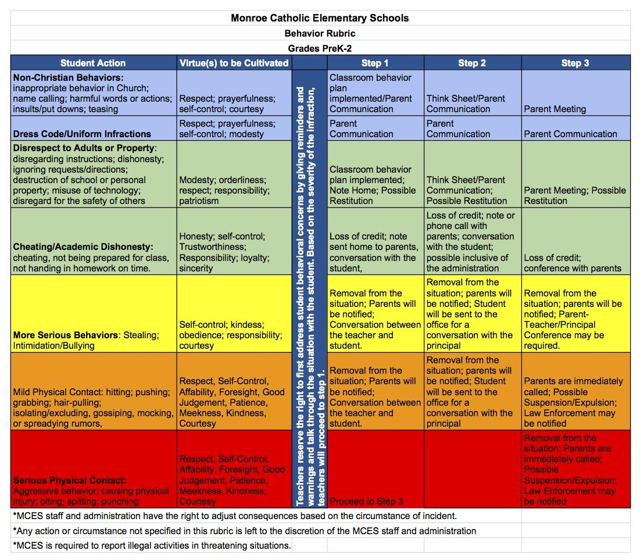

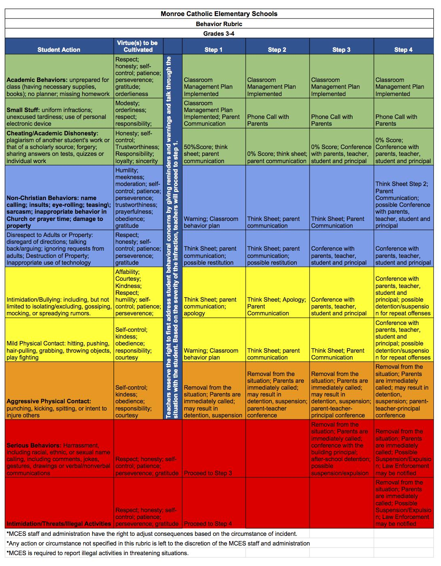

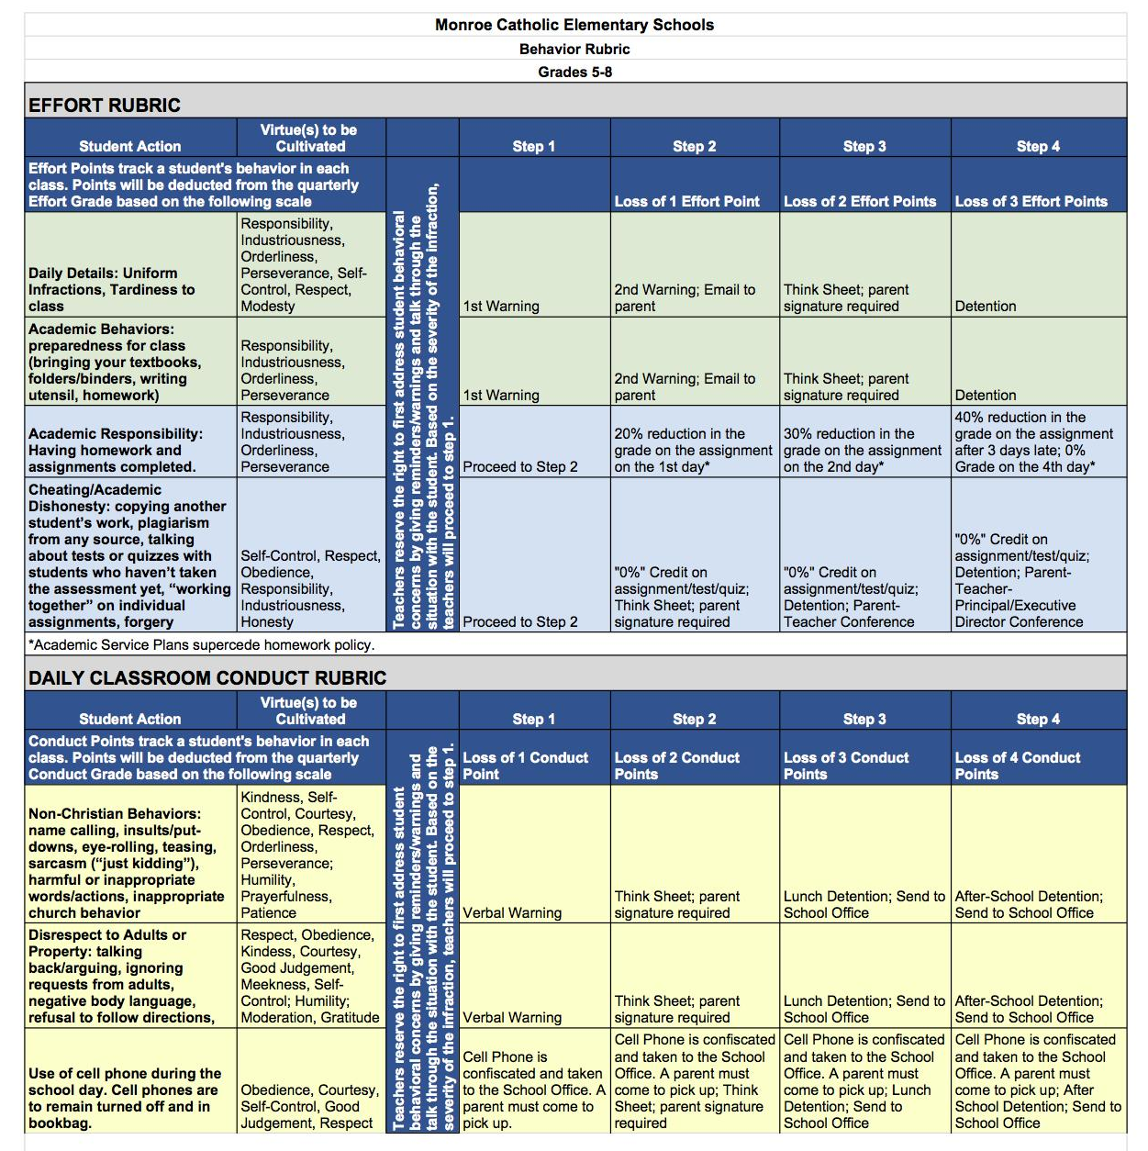
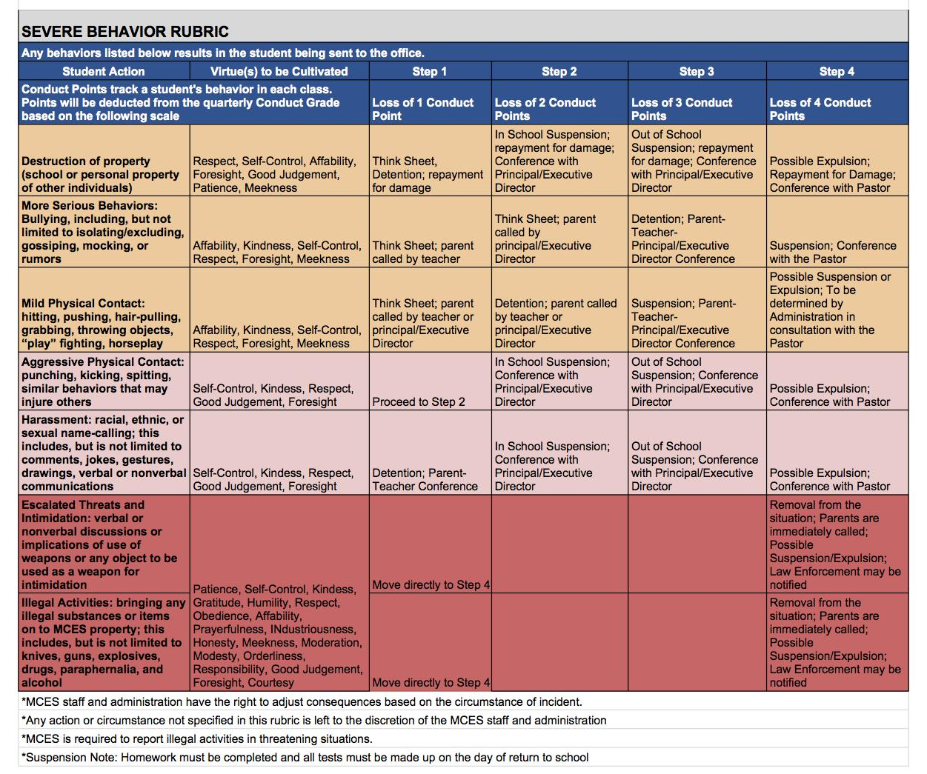

Bus Conduct
Students who ride Monroe Public School buses, St. Mary Catholic Central buses or any other school buses will not engage in any of the following behaviors: violation of safety procedure; fighting, pushing, tripping; littering; smoking, lighting matches, possession of lighter; excessive noise, shouting, whistling; unacceptable language, gestures; any rude, discourteous annoying behavior; throwing things; spitting, extending body parts out bus window, tampering with radio; weapons, riding unassigned bus, moving while bus is in motion.

Steps of Discipline for Bus Behavior
- Verbal warning
- Written warning with call from parent to transportation department to confirm receiving the misconduct notice and set up a conference if necessary.
- One to five day bus suspension
- Six to ten day bus suspension
- One month bus suspension
- Suspension from the bus for balance of the year

Middle School Dances
Students in grade seven and eight may attend dances. The Catholic Schools in the Vicariate take turns in hosting the dances and set the dance dates and locations annually. Any student who attends the dances must sign, and have on file in their school, a copy of the Monroe Vicariate Dance Guidelines. Students and parents will be held accountable according to these guidelines. Violations of guidelines may result in disciplinary actions.

Harassment, Bullying and Abuse
Students and parents of Monroe Catholic Elementary Schools are expected to avoid harassing, bullying, and abusive behaviors. Such behaviors will not be tolerated and disciplinary action will be promptly taken. Student to student harassment may be deemed abuse when the age, maturity or developmental differences between the students are significant.

The school agrees to:
- Provide active supervision during non-academic as well as academic times
- Consistently investigate reports of bullying
- Communicate and teach Christian values which uphold the dignity of each person and contribute to the formation of a healthy and morally sound lifestyle among its members
- Impose progressive penalties or consequences for repeated violations

Search and Seizure
Because school officials have a legitimate interest in the personal safety and protection of all students within their care and custody, there is a right to search for and seize weapons or other dangerous or illegal objects, where the school official has reasonable grounds to believe that such are in the possession of a student. Teachers and other staff members shall make the administration aware of reliable knowledge concerning the whereabouts of such materials.

Weapons/Explosive Materials/Pornographic Materials
MCES prohibits the use, possession and/or sale of any item which might be considered a dangerous weapon or object capable of harming in any way the carrier, another person, or another’s property. Any staff person who observes actual or suspected use, possession or sale of such objects will immediately report the incident to the principal. The principal will investigate the incident. If the incident is verified, the student will be sent home for the remainder of the day. Steps of the discipline code will be initiated immediately.

Procedures for Suspension or Expulsion
One or two-day suspensions shall be imposed by the principal upon students who commit violations which warrant suspension. The Principal/Executive Director shall grant the student an informal hearing before imposing suspension. One or two-day suspensions may be either in-school or out-of-school as determined by the principal/executive director. The principal/executive director shall notify the student’s parents/guardians and teacher(s) of the suspension. The student shall be required to submit to the teacher all class work and assignments for the missed day(s) according to the directives of the teacher. Students may be required to meet with a counselor before returning to class.

For extended suspensions or expulsion, unless immediate action is required to promote the safety or security of persons or property involved and before imposing suspensions for more than two days or expulsion of any student, the principal shall give written notice to the student and his/her parents of the reasons for suspension or expulsion. A student who is suspended for an extended period shall return to school at the end of the prescribed period accompanied by his/her parents/guardians. In the case of an expulsion, the Archdiocese of Detroit School Offices will be notified.

DRESS CODE

Uniforms promote a common bonding among the students and provide a means of identification. This unity will create an environment where the students’ focus is on Christian values and education. Neatness, cleanliness, and a well-groomed appearance are expected. Students in kindergarten through grade 8 are required to wear the school uniform. Since buying clothing is a family function, parents are expected to purchase clothing that will meet the standards set forth in the dress code policy. This policy is written so that it is easy for students and parents to adhere to and easy for teachers and administration to enforce.

Shirts for boys and girls
Plain white or navy blue traditional polo shirts, collared, long or short sleeved. No emblems. Collared white or navy blue traditional fold-down turtlenecks and for girls white rounded or Peter Pan collared shirts are also permitted. No emblems. Shirts must be tucked in slacks, shorts, or skirts. T-shirts worn under the school uniform shirt must be solid white with no visible designs or logos.
Slacks for boys and girls
Khaki, pleated or flat front cotton twill slacks are required. Slacks must be worn with belts at the waist – not below the waist or dragging on the ground – not baggy or oversized. Cargos, carpenter, painter, or polyester knits (stretch) are not allowed.
Shorts for boys and girls
Khaki walking shorts, pleated or flat front cotton twill, at the knee or no more than two inches above the knee. Students may wear shorts from August until the end of September and then from the beginning of May until June. Please use your parental discretion during these times.
Skirts
Girls are required to wear plaid (Hunter/Classic Navy Plaid) Land’s End skirts, skorts or jumpers. Skirts and jumpers will be no more than 2” above the knee.
Sweaters for boys and girls (optional)
Navy blue solid, crew neck or cardigan, long-sleeve pullover sweater may be worn. All sweaters must be worn over a white/navy blue-collared shirt or white/navy blue turtleneck.
Full Zip Fleece for boys and girls (optional)
Navy blue with Monroe Catholic Elementary Schools’ logo, can be worn during the school day. All fleece must be worn over a uniform white/navy blue-collared shirt or white/navy blue turtleneck.
Belts for boys and girls
Plain belts, solid black or brown in color are required to be worn with slacks & shorts that have belt loops. If pants or shorts do not have belt loops, then a belt is not required. Oversized belt buckles are not permitted.
Shoes for boys and girls
Comfortable, appropriate, non-athletic looking casual or dress shoes with non-marking soles are to be worn. Colors include shades of brown, black, or navy blue. Tennis or athletic shoe styles in dark colors are not allowed. Shoes must be leather or suede and fully enclosed. Sandals, moccasins, boots with heavy heels, fashion boots, plastic shoes, flip-flops, clogs, crocs or variations of such are not allowed. Heels are not to exceed 1 ½” in height. All shoes must cover the foot completely, including toes and heel.
*IF you select Sperry boat shoes, they are the all leather versions in shades of brown such as tan, brown, khaki or sahara. Sperry Top-Sider shoes must be free of fabric, colors, patterns (including leopard print) or metallic colored leather/suede (including gold). If your child wears this particular brand of shoe, please note the fit of the shoe, as these do not work for all feet types. Please avoid getting them if they seem to "flop" off of your child's foot. Additionally, if you are purchasing these shoes we strongly encourage looking at these particular models of the Sperry shoes: Sperry Top-Sider Authentic Original 2-Eye Boat Shoes, Sperry Top-Sider Mako 2-Eye Boat Shoes, Sperry Top-Sider Audrey Boat Shoes or similar models.
Socks
Girls: ankle socks, knee socks, or tights in navy blue, white, black or khaki may be worn.
Boys: ankle socks or mid-calf dress socks in navy blue, white, black or khaki may be worn.
Cosmetics, Cologne, and Jewelry
Nail polish may not be worn on girls in grades K – 4. Subtle colored nail polish may be worn by girls in grades 5 – 8. Polish should be free of cracks & chips. Body piercing, visible tattoos, make-up and artificial nails are prohibited. Cologne and perfumes are not acceptable. Girls may wear small earrings with no more than one earring per ear. Boys may not wear earrings even if covered. A small crucifix or religious medallion is allowed for a necklace. A reasonable size wrist watch is acceptable.
Hair Coloring for boys and girls
Natural hair color may not be altered or highlighted. Boys’ hair should be off the collar, above the eyebrows (out of eyes), and above the ear lobe.
Head Gear for boys and girls
Girls’ headbands and hair ribbons may be simple and solid in color and match the colors of the school uniform skirt/jumper (Navy, red, dark green, black) or brown, white and the matching plaid head band is also acceptable. Flowers, bows over 3 inch in size and bandanas are not allowed. Hats or caps may not be worn in the school building. This includes out-of-uniform days. The teacher or Principal will have the final say over what causes a visual distraction in the classroom with regards to hairstyles and hair adornments.
Physical Education Dress for boys and girls
Students in kindergarten – grade 5 are required to wear gym attire on physical education days with clean tennis shoes. Students in grades 6 – 8 will wear the regular uniform and bring physical education attire to school to change into on gym day. Specific guidelines and ordering information for PE uniform can be found on the school website, or by visiting Rick’s Sporting Goods - Rick Benson at 242-0774. The PE uniform policy will be strictly enforced. Parents will be promptly notified of concerns.
NOTE: CYO sports is Parish-based, therefore, CYO clothing may NOT be worn with any school uniform. Principals, along with the Executive Director, will have final say for special events throughout the academic school year.

Jeans Days/ Non Uniform days
All clothing shall be within the guidelines of decency and good taste as appropriate for school. The following are not allowed: offensive or political wording or pictures; ragged, torn, tight-fitting, over-sized clothing; bare midriffs, tank tops, low-cut or revealing tops or tops with spaghetti straps unless worn under another shirt. Tennis shoes may be worn; NO sandals or flip-flops for safety reasons. Socks must be worn. Dates for jeans days will be listed on the calendar posted on the website. Specific guidelines for the middle school can be found on the website.

GENERAL SCHOOL INFORMATION

Birthday Celebrations
The health and safety of our Monroe Catholic School students is our top priority. Due to the impact sugary snacks have on the health and behavior of our students, along with the sensitivity/severity of several types of allergies on our campuses, edible birthday treats cannot be passed out at school this year.
Students that would like to bring in birthday treats for their classmates may share something that is non-edible such as pencils, stickers, small toys, etc. Edible birthday treats have too much of an impact on our school day and will be sent home if they are sent to school. We want our children to feel special on their big day but believe we can achieve this through non-edible treats and other special attention in their classroom. Thank you for your cooperation, understanding and attention to this policy.

Party Invitation Policy
Students may hand out party invitations at school as long as every student in the homeroom class is invited. If the party is for a girl and only girls are invited then all the girls from the homeroom must be invited for the invitations to be passed out at school (same goes for boys-only parties). If not everyone is invited to the party then invitations must be sent via the mail, email, etc. but may not be done at school. The MCES directory is available by calling the MCES mainline at 734-241-6335.

Cell Phones
Cell phones or other electronic communication/entertainment devices are prohibited for Kindergarten through fourth grade, including after school during latchkey supervision. Parents will be notified immediately if a cell phone is found and behavioral consequences will result.

Grades 5 through 8 may store cell phones or other electronic communication/entertainment devices in their book bags during the school day as long as they are not seen, heard, or used during school hours or while the student is under the supervision of school staff, including latchkey.

Public Act 155 makes it a felony to photograph, or otherwise capture or record, a visual image for distribution, dissemination, or transmission of recording, photograph, or visual image of an individual having reasonable expectation of privacy. Students are therefore prohibited from taking pictures of each other with cell phones, PDA’s, etc. for transmission. If a student owns a camera/video cell phone, he/she is not allowed to video camera and/or take pictures on school premises before, during, or after school.

Consequences for cell phone use will include behavioral consequences and confiscation of the device, which parents will be required to pick up from the school office.

Change of Address or Phone

If you have a change of address or telephone number, contact the school office immediately. Unlisted telephone numbers will be considered private information unless otherwise directed. It is essential that the school have accurate addresses and telephone numbers, so that in emergency situations, MCES can reach parents or appointed emergency contacts.

Emergency Management Guide
The Emergency Management Guide details how the school will operate during critical incidents affecting students, faculty, staff or facilities. It is designed to provide guidance for personnel who discover, or are notified of, any emergency situation. The written plan is located in the teacher emergency bag near each classroom door and refers to natural disasters, environmental and building disasters etc. Training sessions are held annually with appropriate updates and practices. Please do not call our school buildings during an emergency. Phone lines must remain open for specific directions from emergency officials for the school.

Emergency Closing, Weather and Epidemics
During inclement weather, fog days, or other emergencies, please turn to station WTWR-FM (98.3) or WJR-AM (760) for school closings. Messages will be sent via SchoolReach to all parent numbers in the school database. If Monroe Public School is closed or delayed due to weather, then MCES will follow the same schedule. If a tornado watch/warning or winter storm takes place while the children are at school, they will be kept as safe as possible at school unless a parent personally collects them.

FERMI Emergency Plan
A Fermi Emergency plan is in place. In the event of a radiological disaster, children are bused to Bedford Senior High School , 8285 Jackman Rd., Temperance. MCES students may be picked up following the evacuation in Temperance. Major radio/TV stations will carry directive information to parents. Our students will remain at Bedford High School with our MCES staff until a parent, or an adult designated on the emergency medical form, picks them up. Please do not call the school during an emergency. Phone lines must remain open for specific directions from emergency officials for the school.

MCES Emergency Drills-An Explanation Guide for Students and Families
The following drills take place at each of our MCES campuses. Please review this page carefully so you are able to discuss these precautionary measures with your students to help reinforce at home how and why we practice these drills at school.

Fire Drills:
Fire drill practice takes place to show students how to evacuate the building in the event of a fire emergency. Signs are posted in the rooms to show where the evacuation route is from each room in each building. Students and staff will follow that route to the designated safe location outside of the school, away from potential fire danger. Students and staff will be alerted to the drill by a fire alarm siren or by a verbal message over the school PA system by a member of the school administration team. At the conclusion of the drill the students and staff will be signaled by the administration to go back into the building and resume their classes. Parents will be unable to pick up their children during drills and must wait to the conclusion of the drill to take their children to appointments, home for the day, etc.
In the event of a real fire emergency, parents that come to school to pick up their children must sign their child(ren) out with the classroom teacher from the safety zone outside, after showing photo ID, before taking their children off the MCES grounds.

Tornado Drills:
Tornado Drill practice is done to prepare students and staff for what to do during a severe weather emergency. Signs are posted in the rooms to show where the evacuation route is from each room in each building. Students and staff will be alerted to the drill via a message on the PA system. Students will be expected to sit on the floor of their designated safety zone with their heads covered for the duration of the drill or until the severe weather has passed. Parents will be unable to pick up their children during drills and must wait to the conclusion of the drill to take their children to appointments, home for the day, etc. In the event of a real severe weather emergency, parents that come to school to pick up their children must sign their child(ren) out with the classroom teacher from the safety zone inside the school, after showing photo ID, before taking their children home. **Note: In the event of severe weather, it is at the parents own risk to be moving and evacuating their child(ren) from their designated secure location on the MCES campus.

Lockdown Drills:
Lockdown Drill practice is done to prepare students and staff for what to do during a safety emergency or threat of danger at the school campus. An announcement is made over the PA system allowing students and staff to know that a lockdown is taking place. Teachers will pull down their interior window shades, lock their doors and move the students to a corner of the room away from the windows and the doors (this could be a closet or a storage area). Teachers will keep the students calm and silent while waiting for the drill/emergency to end. There will not be exchange of classes, movement in the hallways or classrooms or around the school grounds. **Under no circumstance may a person enter or exit the school campus during a drill or an actual lockdown. Students, staff and parents must remain in their locations until an all-clear message is given over the PA system by the school administration team.

Shelter in Place Drills:
Shelter in Place Drills are conducted to prepare students and staff for what to do in the event of a potential threat to the campus. An announcement is made over the PA system alerting students and staff that a Shelter in Place is occurring. Teachers would lock their classroom doors but continue on teaching within their classrooms as normal. Limited hallway activity may occur. There will not be any usage of external doors and students and staff must stay in the building until an all-clear is given. **Under no circumstance may a person enter or exit the school campus during a drill or an actual Shelter in Place. Students and staff must remain on campus until an all-clear message is given over the PA system by the school administration team. Parents must wait for dismissal until an all-clear message is given.

Field Trips
School-sponsored field trips are arranged in advance with the Principal’s approval. Written permission from a parent is necessary before a child may participate. Permission forms will be provided by the school and only these forms will be accepted as permission for the trip. Students without written parental permission and a current emergency medical form will not go on the outing. Students not participating in a field trip will be expected to complete daily lessons under the supervision of a fellow teacher in that teacher’s classroom. Although field trips are strongly encouraged, as they enhance the educational programs available at MCES, field trips are privileges afforded to students. Students can be denied participation if they fail to meet academic or behavior requirements.

Before the field trips, teachers will send home a form which outlines such things as the educational purpose of the trip, the cost per students, lunch arrangements, necessary supplies, dress code, departure and return times. All students are expected to abide by the MCES Code of Conduct and Discipline Policy regardless of location. Parents must have a completed Archdiocesan Volunteer Driver form, Criminal Background Check, and have taken the Protecting God’s Children class on file in the school office to drive/chaperone any students on a field trip.

Fundraising
Before any fundraising event is planned, the fundraising form must be completed and approved by the Executive Director. Monroe Catholic Elementary Schools retain final discretion in determining whether a school sponsored event should be cancelled due to any unforeseen or other emergency circumstances. Fundraisers will not be permitted to pay for class trips for kindergarten through grade four. Grades five through eight may fundraise for class trips such as camp, Washington D.C.

Latchkey / Childcare

Latchkey will be provided for MCES children aged 5 -12 at the St. Michael Campus before school (6:30 a.m. until 7:30 a.m.) and after school (2:30 p.m. until 6:00 p.m.). Our staff members are all trained in CPR, First Aid, and Bloodborne Pathogens. Although state regulations require us to have a ratio of one staff member to 18 children, our St. Michael Campus will be staffed to meet a ratio of 1 caregiver to 15 students. St. Mary campus will offer latchkey for the older students in the afternoon only.

Our general mission statement is based on the belief that we can provide much more than after school care; we provide an enrichment program!

MCES LATCHKEY HAS THREE RULES: 1. Safety 2. Kindness 3. Fun

- Fees
Membership Options: We take the total number of days in the school year and divide the charge out into 9 equal monthly payments, with a payment due every month from September-May. If you have had the same membership all year, there is no payment for that membership due in June! PM Memberships also include care on days when school is delayed or closed due to inclement weather. (All prices are subject to change. If you register after September or change your membership type throughout the year, additional payment may be required as determined by the Director. See our Membership and Billing Policies for more information)

AM Unlimited Membership- Student may attend up to five a.m. sessions per week
Price: $30.00 per month for 9 months (Based on a $1.50 per session rate)

AM Standard Membership- Student may attend up to three a.m. sessions per week
Price: $22.00 per month for 9 months (Based on a $2 per session rate.)

PM Unlimited Membership- Student may attend up to five p.m. sessions per week
Price: $176.00 per month for 9 months (Based on a $9.00 per session rate)
*Includes care on days when school is closed or delayed due to inclement weather

PM Standard Membership- Student may attend up to three p.m. sessions per week
Price: $122.00 per month for 9 Months (Based on a $10 per session rate)
*Includes care on days when school is closed or delayed due to inclement weather (must not exceed 3 days of inclement weather or afterschool care within a week).

Full Day Membership
MCES provides Full Day care on days when school is not in session due to teacher work days and holiday breaks. This membership allows your child to attend each of these eighteen Full Days at a discounted rate. You cannot cancel or change this membership.

Price: $40.00 per month for 9 months (total cost of $360.00)

Non-Membership Options:
Drop-In Care- You may choose to register your child with us but not have a membership. Drop-In Care allows parents to send their child only as needed and to be billed only for the days a child actually attends. Fees for this service will be billed on the next month invoice. Advanced authorization required to ensure proper staffing. (Registration Fees still apply)
Price: Per Day AM: $4 Per Day PM: $15 Full Day: $30
Other Charges:
Registration: (To be paid when you register)
First Child $25 Each Additional Child $15
Late Payment Fee: $25
Early Drop-off Fee: $1 per minute before 6:30 a.m.
Late Pick-up Fee: $1 per minute after 6:00 p.m.

- Early Drop-off and Late Pick-up Fees
Using the St. Michael clock, parents will be charged $1.00 for every minute a child is dropped off before 6:30AM and a $1 late pick-up fee for every minute after 6:00PM. If parents bring a child early, they risk having no supervision for him/her. No exceptions are made for bad weather days. It is parents’ responsibility to watch the weather and make appropriate arrangements for children to be picked up on time. As a courtesy, the staff will try to begin calling parents at 6:05PM if they have not arrived. In the event that neither parent can be reached by 6:15, the Emergency contact person will be called. A staff person will stay with every child until he/she is picked up. If an hour has elapsed and no one on the emergency list can be contacted, MCES will call the Michigan Department of Human Services.

For more information on latch key services please contact Amanda Welton at welton@monroecatholicschools.com .

Lunch Program
St. Michael and St. John Campuses do not have hot lunch provided for our students. Parents are encouraged to pack healthy food that empowers students to excel. St. Mary Campus has lunch at St. Mary Catholic Central in the IHM Activities Center. Lunch is a la carte and available for purchase daily. MCES uses an outside vendor: The Bird’s Nest operated by Laura Kreger. Questions should be directed to lkreger@smccmonroe.com.

Lunchtime in the Cafeteria
Lunchtime is supervised by monitors, who are staff members and parent volunteers. Students are required to show the monitors the same respect that they have for their classroom teachers. The attitude and actions of the students while in the lunchroom should reflect the quality Catholic education that they receive both at school and at home. Courtesy and concern for others should be the rule, and not the exception. The following is a list of lunchroom rules. This is not meant to be a definitive list, nor does it address all areas of concern to the fullest. Our major purpose in reminding parents and students of these policies is to provide each child with a safe environment to enjoy their lunch while they respectfully visit with their peers.

Show respect to all adults and peers.
Walk in the lunchroom.
Use proper language and speak quietly.
Use proper table manners.
Sit at the designated classroom table.
Raise your hand if you should need to leave the table.
Clear table, floor and chairs before leaving.
Sit in chairs properly.
Keep all food in the cafeteria.
Be respectful during prayer.

Choosing to ignore these rules will result in disciplinary actions.

Parent Communications
Parent Orientation is held at the beginning of each school year. The purpose of the meetings is to introduce the school staff and update the community about improvements and enhancements to our curriculum and to familiarize our new and current families with policies, procedures, schedules, and programs for the school year.

A school calendar is published and updated at www.mcesmonroe.com - - found under About Us - - Calendar. Family communication is sent electronically through SchoolReach Instant Parent Contact.

Teacher communication is in the form of a weekly newsletter sent home in the child’s folder and/or accessed via the school website on the teacher page.

Parent Concerns
Parents/guardians with concerns involving a student and/or teacher should first attempt to address the concern with the teacher. Teachers are not available to make or receive calls between 7:45 – 2:30. If e-mailing please allow a reasonable amount of time (within 24 hours) for a response. Again, teachers are teaching all day, not checking e-mail. Do not contact teachers at home or on their cell phones unless they have requested you to do so. If attempts to resolve concerns with teachers have failed, administrators should be contacted.

Recess
Grades K through 5 classroom teachers are responsible for scheduling morning and/or afternoon recess breaks (indoor or outdoor). The daily schedule for recess will be determined by the teacher. It is the responsibility of the parents to ensure that their child is adequately dressed for daily recess.

Visitors
Parents are encouraged to visit the school frequently and actively participate in the education of their child. For the protection of the students, all visitors are to report to the office upon entering the school building. Parents/guardians and visitors must check-in at the school office before proceeding to any given class or any other part of the school building. They should also ensure that they sign out when leaving in case of any emergency when we would need to know who is in the building.

Asbestos and Radon
In compliance with Asbestos Hazard Emergency Response Act of 1986, MCES must issue this annual report to you regarding the status of asbestos in our school.

Periodic surveillance/inspections are conducted at the school buildings. Accredited inspectors not only check the conditions of asbestos, but reassessed operations and maintenance procedures that will keep this material in good condition. All three MCES campuses were inspected in fall 2014.

Detailed awareness and training classes for school maintenance and custodial personnel have been conducted and will continue. Management plans are available for inspection Monday through Friday during normal school hours. The Management Plan is designed in an effort to ensure that any potential health hazard from asbestos is eliminated.

Pesticides
As part of Monroe Catholic Elementary Schools pest management program, pesticides are occasionally applied. You have the right to be informed of any pesticide application made to the school grounds or buildings. In certain emergencies, pesticides may be applied without prior notice, but you will be provided notice following any such application. If you need prior notification, please complete the notification letter that was sent home during September or request a notification letter in the school office providing the school with your name, address, and telephone. Pesticides (Health, Athletics, Phys. Ed & Safety) Aug. 2009.

CODE OF CONDUCT FOR VOLUNTEERS
Our children are the most important gifts God has entrusted to us. A volunteer must strictly follow the rules and guidelines in this Code of Conduct for Volunteers as a condition of providing services to the children and youth of our archdiocese.

A volunteer must:
- Treat everyone with respect, loyalty, patience, integrity, courtesy, dignity and consideration.
- Avoid situations where he or she is alone with children and/or youth at Church activities.
- Use positive reinforcement rather than criticism, competition or comparison when working with children and/or youth.
- Refuse to accept expensive gifts from children, youth or their parents without prior written approval from the pastor or administrator.
- Refrain from giving expensive gifts to children and/or youth without prior written approval from the parents or guardian and the pastor or administrator.
- Report suspected abuse to the pastor, administrator or appropriate supervisor and the local Child Protection Services agency. Failure to report suspected abuse to civil authorities (by required reporters) is, according to the law, a misdemeanor.
- Cooperate fully in any investigation of abuse of children and/or youth.

A volunteer must not:
- Smoke or use tobacco products in the presence of children and/or youth.
- Use, possess or be under the influence of alcohol at any time while volunteering.
- Use, possess or be under the influence of illegal drugs at any time.
- Pose any health risk to children and/or youth through fevers or other contagious situations.
- Strike, spank, shake or slap children and/or youth.
- Humiliate, ridicule, threaten or degrade children and/or youth.
- Touch a child and/or youth in a sexual or other inappropriate manner.
- Use any discipline that frightens or humiliates children and/or youth.
- Use profanity in the presence of children and/or youth.

A volunteer working with children and/or youth is subject to a thorough background
check, including criminal history. Any action inconsistent with this Code of Pastoral Conduct or failure to take action mandated by this Code of Pastoral Conduct may result in removal as a volunteer with children and/or youth.

The following is a reprint from the Code of Pastoral Conduct For Priests, Deacons, Pastoral Ministers, Administrators, Staff and Volunteers. The Code of Conduct for Volunteers can be found on the Archdiocese of Detroit website at www.AODonline.org. Click on Promise to Protect Pledge to Heal and then on Volunteer Code of Conduct.

Volunteers
The Archdiocese of Detroit, in following the mandate from the United States Conference of Catholic Bishops, requires all parishes to perform criminal background checks on all parish and school staff and volunteers who may be in a position to have unsupervised contact with children, the elderly or the disabled. The purpose is to ensure all personnel working with the at-risk groups have no misdemeanor or felony convictions that impact the safety of at-risk individuals: children, elderly, handicapped, etc.

All staff and volunteers will receive a copy of the Archdiocesan Background Check Policy and an Authorization form. The completed form is to be returned to the Background Check Administrators through the school office. All information remains strictly confidential.

New staff and volunteers are also required to attend a Protecting God’s Children workshop within six months. Attendance is required for all parish staff and volunteers who have contact with children. If the workshop is not attended, that person’s name is removed from the approved list to chaperone activities, coach, etc. even though there was a successful background check. The parish is required to repeat background checks every seven years and is required to submit compliance information to the Archdiocese. The mandatory screening is a condition of employment or volunteer assignment. The school principal will be provided with a list of staff and volunteers who have submitted an authorization form. Teachers must check with the principal prior to accepting the service of any volunteer whose duties would include unsupervised contact with the children. If a name is not on the list, volunteer service will not be allowed. Please review the Archdiocese of Detroit’s Code of Conduct for Volunteers found in this handbook.

WEAPONS Archdiocese of Detroit, 1995
State law requires the reporting of possession of a “dangerous weapon” to the local law enforcement agency. “Dangerous weapon” includes a firearm, dagger, dirk stiletto, knife with a blade over 3 inches long, pocket knife opened by mechanical device, iron bar or brass knuckles.

If the school participates in Federal Programs (Chapter II, School Milk, Drug Free Schools, Transportation) the school policy must include a provision for expulsion as stated in the Gun Free Schools Act of 1994.

Definitions:
- A weapon is any object which can be used to threaten or injure another. It includes but is not limited to “dangerous weapons” as defined above.
- School premises include the school building, parking lot, playground, lockers, buses, church, and is not limited to these areas.
- Immediate vicinity of the school means a block radius of the school.

Any student discovered to be, or suspected of, carrying, possessing, concealing or transferring a weapon on school premises or in the immediate vicinity of the school shall be immediately excluded from classes pending investigation.

A search can be conducted to verify the suspicion or clarify the discovery. It may include, without prior warning, an inspection and search of a student’s person, pocket (student empties his/her own pockets), book bag, purse, lunch container, locker, desk, etc. Questioning of the same purpose may include questioning by the principal, member of the administrative team, a schoolteacher, the pastor or a person acting in the place of any of these.

If a body search is required, it shall be conducted in the principal’s or pastor’s office or other appropriately private place. Another person of the same sex shall conduct the search of the student with pastor or principal acting as witness.

If a student refuses to cooperate or interferes with a search of a person or possessions or premises: s/he will be warned that refusal to cooperate without legitimate reason will result in disciplinary action up to and including expulsion from school.

Depending on the nature of the weapon, the local police department shall be notified immediately and if possible, the student detained whenever the school has reason to suspect a student may have a weapon or when a weapon is present on school premises. Any student found in violation of this policy is subject to disciplinary action, up to and including expulsion.

If an injury occurs in school, on school premises or in the immediate vicinity, as the result of a student carrying a weapon, the principal and teachers shall endeavor:
- To have students remain calm and avoid panic;
- To notify police and pastor;
- To secure the school;
- To notify and consult with the immediate supervisor or other appropriate party in the Archdiocesan Catholic Schools Office.
The principal may exercise the options to both keep non-school persons out of the school and/or retain students in the school until police have completed their investigation.

Any student determined to have brought a firearm to school will be expelled for a period of not less than one school year. The term “firearm” means:
- Any weapon including a starter gun which will or is designed to or may be readily converted to expel a projectile by the action or an explosive;
- The frame or receiver of any such weapons;
- Any firearm muffler or firearm silencer;
- Any destructive device.

ALCOHOL AND OTHER DRUG USE/ABUSE POLICY
Vicariate of Monroe Catholic Schools

PHILOSOPHY

The Vicariate of Monroe Catholic Schools considers substance, chemical and alcohol abuse a serious social problem. We recognize that the problem is community-wide, resulting in consequences, which impact the school (students, faculty, and families). Our schools will reach out and offer help to any student or staff member who has a problem with substance abuse. We affirm that chemical dependency is a chronic, progressive disease that touches all persons in the dependent’s life. We know from experience that treatment is available and recovery is quite possible. We commit ourselves to facilitating the process of recovery in any reasonable way.

Therefore, our school pledges to provide firm, yet compassionate support and action to any member of our community who is affected by alcohol and/or drug use/abuse.

Finally, we are aware of the power and allure that alcohol and other drugs hold. We commit ourselves to do everything reasonable to keep our school and events free of alcohol and other drugs. We will deal swiftly and firmly with anyone bringing these substances into our schools or school-sponsored activities.

We have set forth a standard of no alcohol or other drug use for all of our schools. We commit to offer support and assistance to these members of our community who choose to live their lives free of alcohol and other drugs.

DEFINITION OF TERMS
ASSISTANCE COORDINATOR (STUDENT OR STAFF): The administrator/counselor/professional who establishes and implements the Student Assistance Program in a school or agency. This person develops policy, works with qualified staff and handles referrals and is primary contact person for issues involving student or staff use/abuse.

CHEMICAL ASSESSMENT: An information gathering and investigation of the extent of alcohol and other drug use/abuse involvement in a person’s life (student, faculty, staff, parent). This assessment will be considered valid when done by a qualified professional specializing in substance use/abuse.

DRUGS: This includes: alcohol or alcoholic beverages in any form; illegal drugs including but NOT limited to those substances defined as “controlled substances” anabolic steroids, human growth hormones or other performance-enhancing drugs; substances purported to be illegal, abusive or performance enhancing (look-like); prescription or over-the-counter substances, and tobacco related products.

DRUG-RELATED PARAPHERNALIA: Any articles used in connection with the consumption or ingestion of alcohol or other drugs, or supporting the ingestion or consumption of said drugs by word or picture.

LOOK-ALIKE DRUGS: Any substance which represents a controlled substance in nature, appearance or effect will be treated as a “drug”. Imitation controlled substances are those that would lead a reasonable person to believe that the substances are a controlled substance.
MOOD MODIFIERS: Substances purchased with or without prescription which alter the mood and functioning of an individual.

SUPERVISED TREATMENT: The in- or out-patient treatment programs and services for chemical dependency, provided by trained professional through a hospital or licensed treatment facility recommended based upon the outcome of a Chemical Assessment.

SUPPORT GROUP: A small (3-5 member) group which has a common element and concern convened to offer help and affirmation to members while learning and exploring issues of common concern together.

TREATMENT PROVIDER: A hospital or licensed agency which administers care and treatment for those with chemical dependency.

In order to ensure the highest possible standards of learning as well as the safety, health, and well-being of students, staff, and families in our community, the Catholic Schools of the Vicariate of Monroe, guided by Christian principles recognizing the dignity of each person, endorse a substance abuse policy which will: aide and encourage students to abstain from the use/abuse of alcohol and drugs, intervene immediately when student use is detected, take corrective disciplinary action when necessary to staff or students, and to work with the involved Treatment Provider to support aftercare for students, staff, and family members.

The Catholic Schools of the Vicariate of Monroe will provide students with information and activities focused on preventing students from using alcohol and drugs. Prevention activities will be within the instructional program, as well as in guidance and counseling, religious programming, athletics, and all aspects of our school family and community involvement. The intervention instituted by our schools will recognize that chemical dependency is a disease and shall be treated as such.

Discipline policies are designed to provide all students with and environment free of alcohol and drugs. Students shall not possess, sell or use drugs, or alcohol, unauthorized medication, or drug-related paraphernalia. Students shall not be under the influence of drugs, alcohol, or look-alike drugs on school premises or at any school sponsored activity. These policies will meet the requirements of the Archdiocese of Detroit, while emphasizing the disease aspect of dependency.

Possessing or using alcohol or drugs, abusive chemicals, or look alikes, unauthorized medication (prescription or over-the-counter), or drug related paraphernalia will result in disciplinary action. When violations of the law are involved, law enforcement agencies can be notified. Exceptions to a disciplinary procedure must be reviewed and approved by the official of the schools.

STUDENT PROGRAMMING
PREVENTION: The goal of the Catholic Schools of the Vicariate of Monroe is to promote healthy, holy lifestyles for our school communities. To accomplish this, we shall support programs, which instill respect for healthy mind and body. Students will learn how the body functions, how personal habits contribute to good health, and how drugs affect the body. The involvement of parents and other community members is essential for the success of our prevention activities.
Instructional programs will assist students in making responsible decisions about the use of alcohol and drugs. Current and accurate information about alcohol and drugs and their effects upon the body is but one component of the prevention program. Other components include instruction and skill development related to self-esteem, goal
setting, decision-making, understanding feelings, conflict management, problem solving, refusal skills, and the development of communication skills.

At the elementary level, all disciplines will assume responsibility for providing instruction about the prevention of drug and alcohol use/abuse. Special emphasis will be found in health, science, and religion areas. Teachers will participate in training programs to enhance their skills in the areas included in prevention instructional programs. The Catholic Schools of the Vicariate of Monroe commit themselves to planning and conduction periodic training sessions for teachers, and to encouraging teacher attendance at community planned programs.

Guidance and counseling personnel will assist teachers with the identification of high-risk students. Counselors/administrators will work with students, and families to maximize the efforts of the school for instruction and treatment. Programs will be offered to parents and other community members to ensure that the community is aware and knowledgeable of services available to them and their children.

INTERVENTION: The Catholic Schools of the Vicariate of Monroe have set a strategy aimed at eliminating drug and alcohol use/abuse by students. Full use of the opportunities and services provided by Monroe County Intermediate School district will be utilized, as will any available community resources available to the Catholic Schools members for assessments, referrals and treatment programs. All intervention and discipline situations will be covered by normal rules of confidentiality to protect the dignity of the individual. Specific procedures are as follows:
- A staff member witnessing the sale, use, possession or distribution of alcohol, other drug or drug-related paraphernalia shall report the incident immediately to the administrator.
- The administrator shall immediately
  - Inform parent/guardian of the event (by phone)
  - Establish a parent/guardian conference within 24 hours, or as soon as possible, of the incident, include in this conference counselor, or other professionals at discretion of administrator
  - Gather data from staff members (that which can be documents) prior to conference.
- In the case of a student who is under the influence of alcohol
or drugs, has alcohol on his/her breath or who is in possession of alcohol or other drugs or mood modifiers, or having on his/her person drug-related paraphernalia, parents shall be notified and required to remove the student from the school until the conference is held.

The conference will be used to set a course of action to remediate the situation depending on the severity of the offense, the cooperation of the parents, and the attitude of the student. Actions may include, but are not limited to:
- Suspension until a parent/guardian conference occurs
- Student participation, with parent/guardian approval, in a support or treatment group
- Compliance with recommendations of the above specialist regarding treatment.

Failure of parent/guardian to cooperate with procedures will result in expulsion/exclusion of the student in compliance with policy mandates of the Archdiocese of Detroit. Should procedures be followed, a second violation will be handled with the same procedure with the understanding that further violation will result in expulsion/exclusion.

The administrator will provide the parent/guardian with information regarding assessment providers. This administrator will verify that appointments are made with assessment providers. Parent/guardian will assure that a copy of the recommendations from the assessment will be provided to the administrator. If treatment is entered, the administrator and treatment provider will assess progress and assist in re-entry to the school setting.

If the initial situation is presented as a medical emergency, the school will respond as it would in any medical emergency, contacting parent/guardian, ambulance transport, etc.

Procedures for emotional trauma such as suicide threats, and other unusual emotional behavior will be handled by the administrator or counselors who will forward such cases to the appropriate licensed agency.

DISCIPLINE: Enforcement of “punishment” for drug/alcohol related situations will be used to assure the safety of all students, while assuring the appropriate treatment for the individual. Parent/guardian and student cooperation in all procedures to determine need and type of treatment is essential. If this cooperation is not forth coming, the student will be expelled/excluded. If laws are violated, the appropriate law enforcement agency can be contacted by the administrator. Distinction will be made between those seeking help, and those observed violating the law. Students seeking help for use/abuse of drugs/alcohol will be referred to the appropriate agency, support group, or counselor by the guidance/administrative official of the school.

When suspected drugs are found, the item will be secured in an envelope, marked with the DATE, TIME, and LOCATION when/where the suspected drug was found. The envelope will be sealed and initialed, then secured until it can be turned over to the appropriate law enforcement agency.

Students in possession of drug related paraphernalia or who use, possess, or are under the influence of alcohol, narcotics, or other drugs including look-alike drugs during school hours or at school sponsored activities are subject to immediate suspension and/or expulsion/exclusion.

First Offense:
The administrator:
- May notify appropriate law enforcement/juvenile agency if circumstances warrant
- Shall notify parent/guardian of the situation and set an immediate conference with them
- Shall suspend the student for violation of policy for appropriate number of days with expulsion pending
  - An assessment is required within five days (by licensed provider) and report made to administrator
  - Parent/guardian and student must agree to fulfill the recommendations of administrator to be readmitted. If student or parent/guardian refused to agree, expulsion/exclusion will occur.

Second Offense:
The administrator shall implement step #1 and 2 above. Expulsion/exclusion may occur.

Distributing/Selling of narcotics, alcohol or other drugs or look-alikes shall result in expulsion/exclusion.
Paraphernalia associated with drugs sold or distributed, shall be treated as possession/sales of alcohol, drugs or look-alikes (see above).

EXTRA-CURRICULAR ACTIVITIES

Students in extra-curricular activities may forfeit the privilege of participation. Guidelines which apply to all students exist in the athletic handbook for the league and the school.
MAKE-UP WORK

The right to make-up assignments missed during a suspension and to be granted credit for that work shall be determined by the administrator after a review of circumstances. When make-up work is permitted, it shall be the responsibility of the student to take the initiative to obtain assignments. It will be the responsibility of the instructor to give and correct assignments. IT WILL NOT be the responsibility of the instructor to provide additional instruction.

AFTERCARE

Primary aftercare responsibility for students returning from a treatment program rest with the parent/guardian the student, and the treatment program. School staff will work cooperatively with these to facilitate the after care plan.

SEXUAL, RACIAL, ETHNIC HARASSMENT POLICY
It is the policy of the Archdiocese of Detroit and Monroe Catholic Elementary Schools to make every effort to provide an educational environment as well as a work environment, free from all forms of harassment. Each individual faculty, staff member, student, or others who are in a working relationship with the school, is entitled to work/attend school in an environment free from discriminatory practices, including sexual, racial, ethnic and other forms of illegal harassment. All will be held to standards of conduct which ensure that the school is free from harassment.

All students are expected to treat all persons, including each other, with respect and dignity. Accordingly, racially, sexually, or ethnically inappropriate behavior will not be tolerated by the MCES community. Inappropriate behavior means unsuitable touching, gestures, or/and language of an offensive nature, directed toward faculty, staff, or students. Specific examples include, but are not limited to, the following:

--Touching another individual in a sexually explicit or arousing way;
--Making obscene gestures or engaging in other actions of a suggestive or degrading nature;
--Making insulting, disparaging, or otherwise offensive comments about another individual’s physical characteristics or attributes;
--Suggesting through words, gestures, or in writing that another individual student, and/or members of that individual’s family, are involved in inappropriate sexual activity, or that their lifestyle is in any way inferior due to ethnic or racial customs;
--Deliberately taking any action, through the use of drawings, notes, sounds or any other means, calculated to cause another individual shame or embarrassment; and
--Requesting, suggesting, and/or inviting any form of sexual activity between oneself and another individual.

Racial, ethnic or sexual harassment is completely contrary to and unacceptable in a Catholic educational environment and will not be tolerated. Such behavior will result in disciplinary action, up to and including expulsion from school.

Any individual who believes that he or she has been subject to harassment should promptly report this to the Principal. An investigation will be undertaken and appropriate action taken.

ELECTRONIC INFORMATION ACCESS AND USE FOR EDUCATIONAL PURPOSES

Monroe Catholic Elementary Schools (MCES) encourage and strongly promote the use of electronic information technologies in educational endeavors. The School provides access to electronic information resources in a variety of formats, and for the development of information management skills. Together these allow learners to access current and relevant resources, provide the opportunity to communicate in a technologically rich environment and assist them in becoming responsible, self-directed, lifelong learners.

The School has developed this Electronic Information Access and Use For Educational Purposes Policy (this “Policy”) to govern the access, use and security of School Systems (defined below). Every User (defined below) must read, sign and abide by this Policy.

For the purposes of this Policy, the following capitalized terms have the meanings ascribed to them below. Additional capitalized terms are defined within this Policy.

(a) “PEDs” means portable electronic devices, including, without limitation, laptop computers, cellular telephones, pocket personal computers, handheld computers, cameras, video recorders, sound recording devices and all forms of personal digital assistants (“PDAs”).

(b) “School Confidential Information” means all confidential and/or proprietary information and materials of the School, its faculty, administrators, students, employees and/or third parties with which the School does business.

(c) “School Electronic Information” means all electronic information (including the School Confidential Information), communications or activity created, sent, received, stored and/or otherwise used on behalf of the School, whether or not the School Systems are used to create, send, receive, store or otherwise use that information or those communications. The School Electronic Information includes voicemail messages on the School Equipment.

(d) “School Equipment” means any and all electronic devices owned, leased or operated by or for the benefit of the School, which have the capability of creating, sending, receiving, storing and/or otherwise using electronic information, materials and/or communications, including, but not limited to, pagers, computers, servers, disk drives, scanners, photocopiers, printers, fax machines, telephones and PEDs. School Equipment includes all operating software, application software and firmware owned and/or licensed by the School, which resides and/or is embedded in any the School Equipment.

(e) “School Networks” means all School voice and data systems, including, without limitation, the School’s Internet, intranet and extranet systems.

(f) “School Systems” means the School Equipment and the School Networks.

(g) “Users” means any individual who accesses and/or uses School Systems, including, without limitation: (i) School full time, part-time and temporary faculty and/or employees; (ii) School third party contractors, vendors, consultants, representatives and agents, as well as their full time, part-time and temporary employees; and (iii) parents, students and volunteers.

(h) “User Equipment” means electronic devices that are continuously intermittently connected to School Systems, or a component thereof, which are not owned or leased by the School, including, without limitation, User-owned computers, pagers, telephones, fax machines and PEDs. User Equipment without connectivity to School Systems does not fall under the purview of this Policy.

This Policy applies to all Users and to all School Systems, User Equipment, School Confidential Information and School Electronic Information.

To the extent this Policy applies to School faculty and/or employees, this Policy supplements, but does not replace, the School’s Faculty Handbook. The terms of this Policy will govern any conflict or inconsistencies with the terms of such handbook. Any School faculty and/or employee who violates this Policy may be subject to disciplinary action, up to and including termination.

To the extent this Policy applies to students, this Policy supplements, but does not replace, the School’s Code of Conduct. The terms of this Policy will govern any conflict or inconsistencies with the terms of such Code of Conduct. Any student who violates this Policy may be subject to disciplinary action, up to and including suspension and/or expulsion.

To the extent this Policy applies to third parties, this Policy supplements, but does not replace, School’s agreements with such third parties. The terms of this Policy will govern any conflict or inconsistencies with the terms of such agreements. Third parties who violate this Policy may no longer be considered eligible for access to and/or use of School Systems, School Confidential Information and/or School Electronic Information. A third party’s violation of this Policy shall also be considered a material breach of its agreement with School, entitling School to terminate such agreement for cause.

The School Systems, School Confidential Information and School Electronic Information are the School’s property and may be used solely for educational purposes and/or the School’s operational activities. Each User must take all necessary steps to prevent unauthorized access to or use of School Confidential Information and School Electronic Information. Unless otherwise directed by School, or permitted or required by this Policy, Users may not: (a) take, retain or use School Confidential Information and/or School Electronic Information for User’s own benefit; (b) disclose School Confidential Information and/or School Electronic Information to any other entity or unauthorized person without the written permission from a School officer; (c) delete, encrypt, password protect, or retain electronic files containing School Confidential Information and/or School Electronic Information (including emails and attachments); or (d) take any other action that impairs, restricts, limits, or impedes School’s ability to have full access to and use of its School Confidential Information and/or School Electronic Information. Upon request, User shall return to School all School Confidential Information and/or School Electronic Information, and otherwise fully cooperate with and assist School in ensuring School’s ability to have full access to and use of School Confidential Information and/or School Electronic Information. Such cooperation and assistance may include, but is not limited to, removing any password protection, encryption or other proprietary format on School Confidential Information and/or School Electronic Information.

The School retains the right to search, monitor, access and/or review all School Systems, School Electronic Information and all other electronic and voice mail communications, computer files, databases and any other electronic transmissions contained in or accessed by School Systems, at any time, with or without notice, at School’s sole discretion. This may include, without limitation: (a) viewing, printing, downloading and/or listening to emails and voicemails created, sent, received, stored and/or otherwise used in or through School Systems; (b) viewing, modifying and/or removing a User’s electronic mailbox; and/or reviewing audit trails created by School Systems.

No email, voicemail or other information, whether received, sent, stored or used on or through School Systems, is private. Users have no expectation that any information contained on any School Systems is confidential or private to them. The School's System is not a public forum and access to the technology is a privilege and not a right. By using School Systems, Users consent to the access and disclosure of email messages, voicemail messages and other information within School’s organization without restrictions, but subject to School’s legal and contractual obligations of confidentiality. Users should not use School Systems to create, send, receive and/or store information that is personal if it is confidential or sensitive, since such personal information will be considered School Electronic Information if created, sent, received and/or stored using School Systems.

The School makes no warranties of any kind, whether expressed or implied, for any reason regarding the access to, or use, quality or availability of, School Systems, including but not limited to the loss of data. All School Systems are provided on an “as is, as available” basis.

School Responsibility

The School will designate a system administrator who will manage the School Systems and make the final determination as to what is inappropriate use based on this Policy. The system administrator may close an account at any time for infractions or temporarily remove a User account and/or a User’s access to or use of the School Systems for any reason, including, without limitation, to prevent unauthorized activity.

The School will implement filtering software intended to block minors’ access to materials that are obscene, child pornography, harmful to minors, or that the School determines to be inappropriate for minors. However, the School does not guarantee that it will be able to fully prevent any User’s access to such materials, or that Users will not have access to such materials while using School Systems. The filtering software operates only within the School wide area network (WAN) or local area network (LAN). The filtering software does not operate during dial-up access.

The School does not take responsibility for resources located or actions taken by any Users that do not support the purposes of the School.

It shall be the responsibility of all members of the School staff to supervise and monitor usage of the School Network and access to the Internet in accordance with this Policy and the Children’s Internet Protection Act.

Monroe Catholic Elementary Schools (MCES) Network Users

Users will be granted access to appropriate services offered by the School Network. In addition, the following people may become account holders or members of the School Network:

1. Students. Students who are currently enrolled in the School may be granted a School Network account upon agreement to the terms stated in this Policy.

2. Faculty and Staff. Staff members currently employed by the School may be granted a School Network account upon agreement to the terms stated in this Policy.

3. Others. Anyone may request a special account on or use of the School Network. These requests will be granted on a case-by-case basis, depending on need and resource availability.

Privileges and Responsibilities of Users

Privileges

Subject to the terms of this Policy, Users have the privilege to:

- use all authorized School Systems for which they have received training to facilitate learning and enhance educational information exchange.

- access information from outside resources which facilitate learning and enhance educational information exchange.

- access School Networks and the Internet to retrieve information to facilitate learning and enhance educational information exchange.

User Responsibilities

Users are responsible for:
- using School Systems only for facilitating learning, appropriate personal growth and enhancing educational information exchange consistent with the purposes of the School.

- attending appropriate training sessions in the use and care of School Systems.

- seeking instruction for the use of any available technology with which they are not familiar.

- adhering to the rules established for the use of School Systems, in the School or through remote access outside of the School.

- refraining from disclosing, using or disseminating personal identification information regarding students over the Internet without parent or guardian authorization.

- maintaining the privacy of passwords and are prohibited from publishing or discussing passwords. School Network accounts are to be used only by the authorized owner of the account for the authorized purposes.

- students may use e-mail, chat, instant messaging, and other forms of two-way electronic communications only for educational purposes and only under the direct supervision of an adult.

- having all electronic media scanned for virus, dirt, damage or other contamination which might endanger the integrity of School Systems before they are used in School Systems.

- material received, created or distributed using School Systems.

- maintaining the integrity of the electronic messaging system (voice, e-mail, etc.), deleting files or messages if they have exceeded their established limit, reporting any violations of privacy and making only those contacts which facilitate learning and enhance educational information exchange. If a User remains in non-compliance, the system administrator may delete files and messages, freeze the account, and/or close the account.
- preventing material considered pornographic by the School, inappropriate files or files dangerous to the integrity of the School's Systems from entering the School via the Internet or from being reproduced in visual, digital or written format.

- awareness of and adhering to copyright laws and guidelines and trademark laws and applicable licensing agreements in the use of School Systems and in the transmission or copying of text or files on the Internet or from other resources. Users must also comply with all other applicable laws, both state and federal, with respect to their use of the School’s Systems.

- using caution (Buyer Beware) when considering the purchase of goods or services over the Internet. The School is not liable for any financial obligations made nor any personal information provided while using School Systems.

- financial restitution for unauthorized costs incurred or damages or repair necessitated by inappropriate use or access.

- any damages to, or incurred on, User Equipment. Users accessing School Systems on User Equipment do so at their own risk.

- abiding by the rules set forth in this Policy, general School rules, and additional rules as may be established by the School. Local School Committee policies, staff manuals, departmental procedures, and student handbooks may include such rules.

Users are prohibited from:

- using the technology for a “for-profit” business, for product advertisement or political lobbying.

- the malicious use of technology to disrupt the use of technology by others, to harass or discriminate against others and to infiltrate unauthorized computer systems.

- using School Systems to draft, send, or receive inappropriate communications and material including but not limited to, items which are pornographic, obscene, profane, vulgar, harassing, threatening, defamatory or otherwise prohibited by law.

- participating in hate mail, harassment, discriminatory remarks and other antisocial behaviors on the network.

- vandalizing School Systems or any other information technologies (the School's or any others). Vandalism is defined as any attempt to harm, destroy, or disrupt or hack the operation of the School's Systems. Vandalism includes, but is not limited to, the creation or intentional receipt or transmission of computer viruses.

NOTICE FOR DIRECTORY INFORMATION

The Family Educational Rights and Privacy Act (FERPA), a federal law, requires that Monroe Catholic Elementary Schools (MCES), with certain exceptions, obtain your written consent prior to the disclosure of personally identifiable information from your child’s education records. However, MCES may disclose appropriately designated “directory information” without written consent, unless you have advised the school to the contrary in accordance with school’s procedures. Examples include:

- The annual yearbook
- Student directory
- Honor roll or other recognition lists
- Graduation programs
- Sports activity sheets

Directory information, which is information that is generally not considered harmful or an invasion of privacy if released, can also be disclosed to outside organizations without a parent’s prior written consent. Outside organizations include, but are not limited to, local news media and yearbooks.

If you do not want Monroe Catholic Elementary Schools to disclose directory information without your prior written consent, you must notify the school in writing by September of the current school year.

- Student’s name
- Participation in officially recognized activities and sports
- Address
- Telephone listing
- Electronic mail address
- Photograph
- Degrees, honors, and awards received
- Grade level

If you have any questions regarding directory information, please do not hesitate to contact
Mrs. Alicia Marting at 734 241-6335. Thank you.

RIGHT TO AMEND
No attempt is made in this handbook to cover every possible situation, policy, regulation or disciplinary action. It is understood that the Principals and the Executive Director, in frequent contact with the Pastors, are empowered to handle situations not specifically mentioned in this publication. Monroe Catholic Elementary Schools, the campus Principals, and the Executive Director, retain the right to amend this handbook. Parents will be given prompt notification if changes are made.

