MC900304849[1]MC900304849[1]

# Monroe Catholic Elementary Schools

## *2013 Grand Christmas Raffle*

**\*\*\*$100 per Ticket or 5 tickets for $450\*\*\***

***Winning Ticket to be drawn at the***

***Monroe Catholic Schools Christmas Celebration***

**December 5, 2013 (drawing at 7pm) *at the River Raisin Banquet Center***

(Need not be present to win)

*\*\* ONE GRAND PRIZE WINNER \*\**

*$75,000 new untitled 2009*

*Ford Mustang* GT500 Cobra KR*

*or*

*$25,000* in cash*

*The seller of the grand prize ticket wins a Monroe “Out on the Town” Gift Basket*

*Tickets on sale now—December 5, 2013*

*\*If 1,000 tickets are not sold, the drawing will have a single grand prize of $10,000*

*State of Michigan raffle license #R23851*

***Use this convenient form to purchase your car raffle tickets.***

***Please print clearly or type. Make checks payable to MCES***

Please send me _____ ticket(s) for the 2013 Grand Christmas Raffle to benefit MCES. **Tickets are $100 each or 5 for $450**.

CASH:_________ CHECK #__________ MC/VISA/AE#____________________________________ EXP DATE _____________________

Name (as it appears on card): ________________________________________________ Signature (required to process payment): __________________________

Name(s):_________________________________________________________________________________________________________________

Mailing Address:___________________________________________________________________________________________________________

City: ______________________________________ State: __________ ZIP:__________________ Phone: _______________________________

Seller’s Name (must be 18 years old):____________________________________________________

CREDIT A CURRENT FAMILY/ STUDENT AT MCES ~______________________________________________________________________

(This box must be checked to receive family credit.) (Family Name of the MCES Student)

Your car raffle ticket will be mailed to you. Your name and number are recorded at the MCES Executive Director’s office.

Mail to: MCES Grand Christmas Raffle

510 W. Front Street

Monroe, Michigan 48161.

The 2013 Grand Christmas Raffle operates under a State of Michigan Raffle License #R23851.



***Special thanks to our sponsors:***

# Monroe Catholic Elementary Schools

## *2013 Grand Christmas Raffle Car*

**Our raffle vehicle is a new, never titled, silver with blue racing stripes 2009 Ford Shelby GT500KR**

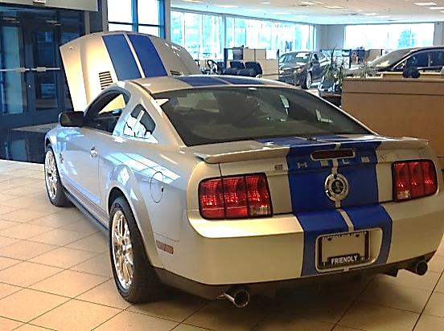The Ford Shelby GT500KR, revealed at the 2007 New York International Auto Show, was released in the spring of 2008. The car is powered by a 540 horsepower 5.4-liter (330 CID) supercharged V-8 version of the base GT500 engine with functional Cold Air Intake and unique calibration. SVT and Shelby announced that 1,000 40th Anniversary Editions will be built for the U.S. in 2008, with another 571 units in 2009. This 1,571 production run matches that of the original 1968 GT500KR. In total, 1,712 units were produced, with the remaining units going to Canada, export markets and military sales.

All KRs were built by AutoAlliance International on the normal Mustang production line and then shipped to Shelby Automobiles Incorporated (SAI) where final assembly was completed. SAI was the manufacturer of record.

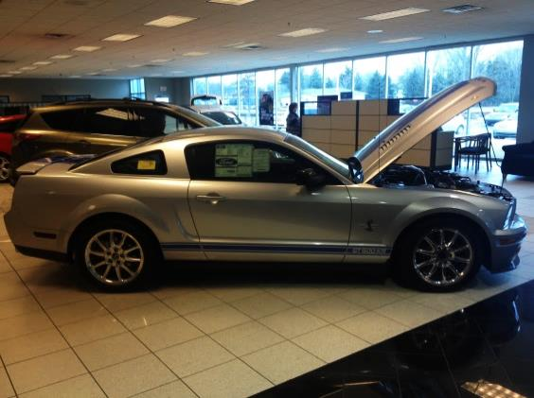The Shelby GT500KR features a carbon fiber composite hood with functional scoops and vents, twist-lock hood pins modeled on the original 1968 KR, a unique carbon fiber splitter, carbon fiber mirror caps, and functional brake cooling ducts. The suspension was tuned by SVT with unique spring rates, dampers, stabilizer bars, and strut tower brace and was sourced from Ford Racing. Unique Goodyear Eagle F1 Supercar tires were developed for the KR with a unique compound. With the same tread pattern as the Eagle F1 Supercar tire on the 2007–2009 GT500 they can only be identified by a unique Goodyear "Wingedfoot" emblem on the sidewall.

The 2008–09 GT500KR draws on styling cues from the classic 1968 "King of the Road" GT500KR model, and the 2008 model includes "40th Anniversary" badging; both years will have availability of standard GT500 colors with "LeMans" stripes, and Carroll Shelby signature embroidered seats. The GT500KR's starting price was $120,000.95

The GT500KR was featured prominently in the new Knight Rider television series on NBC. One of the main characters of the show was KITT, an advanced Artificial Intelligence housed in a GT500KR. Also, in the return of the show, KARR was also a GT500KR.

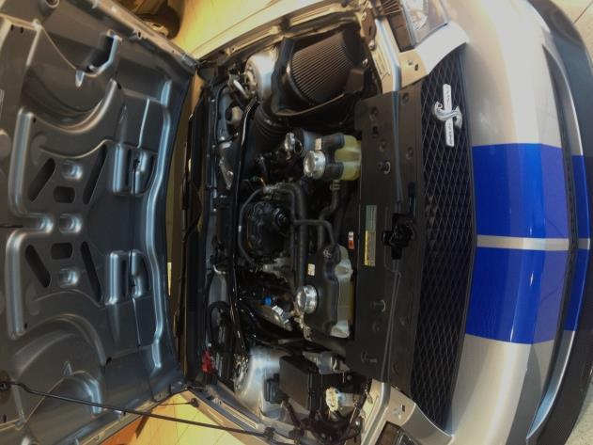**Specifications:**

* Front engine, RWD, 4-passenger, 2-door coupe
* Supercharged DOHC 32 valve V8 engine[23]
* 330 CID (5408 cc) displacement
* Power: 540 hp (403 kW; 547 PS)
* Torque: 510 lb·ft (691 N·m)
* 6-speed manual transmission
* 3.55 differential ratio
* 18 x 9.5" Alcoa wheels with unique Goodyear Eagle F1 Supercar tires (front: P255/45ZR18 rear: 285/40/ZR18)
* 3,920 lb (1,780 kg) curb weight
* 107.1 in (2,720 mm) wheelbase
* 188×73.9×54.5 in (4.78×1.88×1.38 m)

