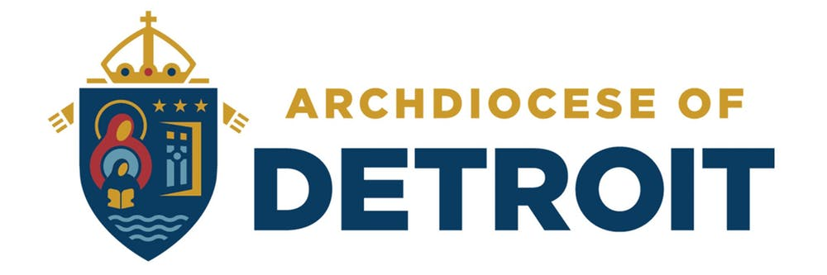
PARENT INFORMATION LETTER
2019-20 School Year
ANNUAL TUITION ASSISTANCE PROGRAM

Archdiocese of Detroit will be contracting with FACTS Management, a third-party contractor, to process the tuition assistance applications for families who wish to apply for the Archdiocesan Tuition Assistance Grant. It is important to note that the independent contracts and other services that FACTS Management provides are separate from the Archdiocesan Tuition Scholarship which is funded by the Stewards for Tomorrow Campaign and the Archdiocesan Endowment.

What is the Archdiocesan Tuition Assistance Program?
As a result of the Stewards for Tomorrow Campaign and the establishment of the Archdiocesan Endowment, the Archdiocese of Detroit extends tuition assistance grants to Catholic families, who reside in the Archdiocese of Detroit, with children in grades K-12 attending Catholic Schools.

Awarding Amounts
All awards are based on the calculated financial need determined from the information on the FACTS online application and the required financial documentation The award amounts will fall into one of the following tiers:
• Tier I - $1100.00 • Tier II: $ 950.00 • Tier III: $ 800.00
This process allows for greater assistance based on need. The application and all supporting documents must be in by the deadline date of April 30, 2019 in order to be eligible for one of the three tiers. Round two applications will be accepted, but will only be eligible for Tier III.

Frequently Asked Questions
Must financial need be demonstrated?
Yes, financial need must be demonstrated. The FACTS Grant & Aid Form must be completed by each family applying, and submitted through the on-line application process. Employment, number of children, and ability to pay will be primary factors in determining need. The evaluation will also assess the families’ ability to pay.

How do I apply?
Applications can only be completed online. The FACTS Student Grant & Aid link should be on your school’s webpage. It will also be available on the Archdiocesan website by going to aod.org/Catholic Schools/Tuition Assistance. Look for the FACTS Grant & Aid link. There is a $30 on-line application fee. Please follow the payment instructions indicated on the application. Receiving an award in previous years does not guarantee an award for the current year.

Is the Pastor’s Signature Form Mandatory for the AOD Grant?
Yes, the pastor’s signature form is mandatory. You must be an active parishioner in a Catholic parish within the Archdiocese of Detroit. The Pastor Signature Form is available on the AOD website and must be submitted to your school’s tuition assistance coordinator to be entered into your application. The school cannot complete this final step until your application shows “Complete” in the FACTS system. This will ensure that you have met all of the eligibility requirements of the program. If the pastor signature form is not turned in your application cannot be processed under the requirement of the Archdiocese grant guidelines.

Do some schools have independent contracts with FACTS?
Yes, in fact SMCC has an independent contract with FACTS for their tuition program. Independent school contracts may have different guidelines, deadlines, and required fees to qualify. It is important to note that although some schools may have the application available to their constituents before others; it does not influence the order of awarding grants. If you are applying to a school that has its own financial aid grant, make sure you check the school and the AOD on your FACTS online application in order to be considered for both grants.

TIME-TABLE FOR 2019-2020 ARCHDIOCESAN TUITION ASSISTANCE PROGRAM
Now Online Application open for Round 1
4/30/2019 Round 1 DEADLINE for on-line applications
Week of 5/21/2019 Award notifications announcing Round 1 grant awards or denials will be emailed to applicants and will be available online for schools.
5/15/2019 AOD Online Application is open for Round 2
6/30/2019 Round 2 DEADLINE for on-line applications
Week of 7/22/2019 Award notifications announcing Round 2 grant awards or denials will be emailed to applicants and will be available online for schools.
8/31/2019 Schools will receive a Tuition Assistance Grant report to complete and return to the Office of Catholic Schools for processing checks if all information is validated.

Archdiocese of Detroit Award Eligibility Criteria
All of the following criteria must be met in order to be eligible for an Archdiocesan Tuition Assistance Program Award.
• The FACTS online application must show “Complete” in the FACTS system by the deadline date.
• The family must be Catholic.
• The family must be active parishioners in a parish that is within the Archdiocese of Detroit.
• Students must be in grades Kindergarten – 12th.
• The Pastor Signature Form must be signed and given to the tuition Assistance coordinator at your school, and they must mark the form received, in the FACTS system, by the deadline dates indicated above.

Tax Extensions and Late Applications
• Any application that does not show “Complete” in the FACTS system by the 1st Round deadline will not be eligible for 1st round consideration.
• Families who have completed an extension for filing their 2018 1040 federal tax return may submit their 2017 1040 federal tax return along with their 2018 W2’s (if applicable).
• Families who file extensions will only be eligible to be considered for the 2nd Round 3rd tier award of $800.00. Note: The application must still show “Complete” and the pastor’s verification must be checked in the FACTS system by the 2nd Round deadline date.
• Applications that show “Complete” in the FACTS system but do not have the Pastor’s Signature Form marked as received will not be eligible to receive an award
• *New Process* Parents must submit proof of tax extension from a tax preparer to the school to be considered. The Office of Catholic Schools is no longer involved in this process.

Additional Information
• Complete only one application per family regardless of the number of school children or where they attend school. Please make sure all eligible student names are included on the application. You may use an additional sheet if needed.
• If one child in your household (K-12) receives the grant, all children in your household will receive the grant (K-12) that meet the eligibility requirements.
• FACTS is the sole evaluator for the Student Aid Form process.
• The receipt of other financial assistance such as parish, vicariate or Catholic school scholarships/grants, does not exclude the awarding of an Archdiocesan grant.
• All Catholic families in the Archdiocese of Detroit are eligible for the grant providing the child(ren) meet the above criteria and are enrolled in a Catholic school for the current school year.
• There is no appeal process.

Questions Regarding the Process
FACTS Management is the third party contractor that processes the Archdiocesan Tuition Assistance Grant applications. Questions regarding the on-line application should be directed to FACTS Management at (866) 441-4637.
Locally questions regarding the tuition assistance process can be answered by Hussey, Laureen - MCES Finance Director hussey@monroecatholicschools.com All award decisions are made by the Archdiocese of Detroit based on eligibility and financial need, not by MCES.

