Raffle FAQs

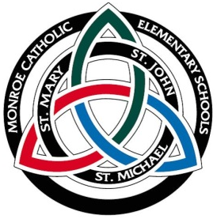
2015 MCES Christmas Raffle and Euchre Tournament
All ticket purchasers are invited to attend for fun and fellowship!

This fundraiser is designed to help each family save $200 in tuition costs. Raffle ticket monies are due by Wednesday, November 18, 2015.
  - Not participating in the fundraiser and your oldest child is K-8th grade a payment of $200 is due now.
  - Not participating in the fundraiser and your oldest child is PreK a payment of $100 is due now.
  - After November 20, 2015 a payment of $200 for oldest K-8th and $100 for PreK will be added to your tuition account, per the MCES enrollment agreement.
- Ticket sales can be returned to any of the 3 school offices and must be returned in a sealed envelope with:
  - Oldest student name on the outside of the envelope
  - Oldest student name on the sold ticket
  - Payment with ticket stub(s) enclosed
  - Each ticket stub must be accompanied with a payment
- Friday, November 20, 2015 the winning tickets will be drawn at the Christmas Euchre and Raffle Drawing party at 7:00 p.m. at the St. Michael Campus. Also, There will be a “fishbowl” raffle and the tickets will be drawn that evening.
  - To play in the euchre tournament there is an entry fee.
- All raffle tickets (sold and unsold) must be returned to one of the school offices by
November 18, 2015. The State of Michigan requires accounting of all raffle tickets.
- Prizes for the Grand Christmas Raffle are one $5,000 grand prize, one $1,000 prize and one Apple iPad mini.
- Raffle tickets are assigned to you by number. Please do not trade with other families.
- After selling your required (8) raffle tickets, families can request more tickets. For every ticket sold over the required 8, families will receive either a $5 credit to their tuition account or if your account is paid in full you will receive a rebate check ($5 per ticket over the original 8) paid to you during second semester. Please do not deduct the rebate amount while making additional sales.
- Sales of raffle tickets are considered gambling by the State of Michigan and raffle tickets cannot be sold by anyone under the age of 18.
- Please direct all questions to the MCES mainline at (734) 241-6335.

