“Back to School Welcoming”
MCES & Canvas Event for St. John’s Campus Students Grades 2-4
Sunday, September 21, 2014
St. John Campus Cafeteria
2 p.m. – 4 p.m.
$20 per student/Projects for Boys & Girls

**Students need to be “accompanied” to this event to provide any assistance that may be required.**

Return your Registration Form with your project selection and payment by Monday, September 15, 2014.
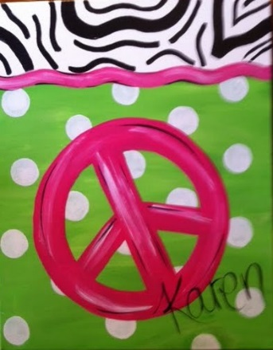

========================================================================================================================
Name: Contact Info:
Project (circle one) Peace Sign Cross Design your Helmet

