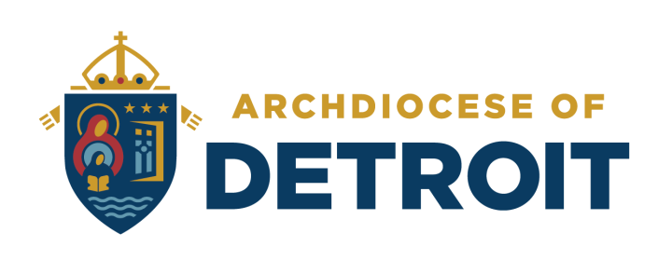

PARENT INFORMATION
ANNUAL TUITION ASSISTANCE PROGRAM

The Archdiocese of Detroit uses FACTS Management, a third-party contractor, to process tuition assistance applications for families who wish to apply for the Archdiocesan Tuition Assistance Grant. It is important to note that the independent contracts and other services that FACTS Management provides are separate from the Archdiocesan Tuition Scholarship.

What is the Archdiocesan Tuition Assistance Program?
Through the generosity of donors to the Stewards for Tomorrow Campaign, an endowment fund was created which provides tuition assistance grants to our Catholic families. Each year, awards will be made to offset the K-12 tuition expenses for children of Catholic families who both reside within the Archdiocese of Detroit AND whose children attend Catholic schools located within the boundaries of the Archdiocese of Detroit.

Award Amounts
All awards are based on the calculated financial need determined from the information on the FACTS online application and supporting financial documentation. The award amounts will fall into one of the following tiers:

- Tier I - $1,100
- Tier II: $ 950
- Tier III: $ 800

The deadline for submission of your application and supporting documentation is April 30th for the upcoming school year.

Frequently Asked Questions

Must financial need be demonstrated?
Yes, financial need must be demonstrated. The FACTS Grant & Aid Form must be completed by each family and submitted through the online application process. Employment, number of children, and ability to pay will be primary factors in determining need. The evaluation will also assess a family’s ability to pay.

How do I apply?
Applications can only be completed online. The FACTS Student Grant & Aid link should be on your school’s webpage. It will also be available on the Archdiocesan website by going to https://www.detroitcatholicschools.org/tuition-assistance-scholarships. The FACTS Grant & Aid link should also be on your school’s website. There is a $30 on-line application fee. Please follow the payment instructions indicated on the application.

Receiving an award in previous years does not guarantee an award for the current year.

Is the Pastor’s Signature Form Mandatory for the AOD Grant?

Yes, the pastor’s signature form is mandatory. You must be an active parishioner in a Catholic parish within the Archdiocese of Detroit. The Pastor Signature Form is available on the AOD website and must be submitted to your school’s tuition assistance coordinator to be entered into your application. The school cannot complete this final step until your application shows “Complete” in the FACTS system. If the pastor signature form is not turned in your application cannot be processed under the requirement of the Archdiocese grant guidelines.

Do some schools have independent contracts with FACTS?
Yes, some schools have independent contracts with FACTS. Independent school contracts may have different guidelines, deadlines, and required fees to qualify. Check with your school for details.

If you are applying to a school that has its own financial aid grant, make sure you check the school and the AOD on your FACTS online application in order to be considered for both grants.

TIME-TABLE FOR ARCHDIOCESAN TUITION ASSISTANCE PROGRAM

January 22 Online Application open for Round 1
April 30th Round 1 DEADLINE for on-line applications
May 15th AOD Online Application is open for Round 2
End of May Award notifications announcing Round 1 grant awards or denials will be emailed to applicants and will be available online for schools
June 30th Round 2 DEADLINE for on-line applications
Mid July Award notifications announcing Round 2 grant awards or denials will be emailed to applicants and will be available online for schools
End of August Schools will receive a Tuition Assistance Grant report to complete
and return to the Department of Catholic Schools for processing

Archdiocese of Detroit Award Eligibility Criteria

All of the following criteria must be met in order to be eligible for an Archdiocesan Tuition Assistance Program Award:
- The FACTS online application must show “Complete” in the FACTS system by the deadline date
- The family must be Catholic
- The family must be active parishioners in a parish that is within the AOD
- Students must be in grades Kindergarten – 12 in Catholic Schools located within the AOD
- The Pastor Signature Form must be signed and given to the tuition assistance coordinator at your child(ren)’s school, who must mark the form received in the FACTS system by the deadline dates indicated above

Tax Extensions and Late Applications
- Any application that does not show “Complete” in the FACTS system by the 1st Round deadline will not be eligible for 1st round consideration.
- Families who have completed an extension for filing their current year’s 1040 federal tax return may submit their previous year’s 1040 federal tax return along with their current tax year’s W-2s (if applicable).
- Families who file extensions will only be eligible to be considered for the 2nd Round 3rd tier award of $800. Note: The application must still show “Complete” and the pastor’s verification must be checked in the FACTS system by the 2nd Round deadline date.
- Applications that show “Complete” in the FACTS system but do not have the Pastor’s Signature Form marked as received will not be eligible to receive an award
- *New Process* Parents must submit proof of tax extension from a tax preparer to the school to be considered. The Department of Catholic Schools is no longer involved in this process.

Additional Information
- Complete only one application per family regardless of the number of school children or school. Please make sure all eligible student names are included on the application.
- If one child in your household (K-12) receives the grant, all children in your household will receive the grant (K-12) that meet the eligibility requirements.
- FACTS is the sole evaluator for the Student Aid Form process.
- The receipt of other financial assistance such as parish, vicariate, or Catholic school scholarships/grants, does not exclude the award of an Archdiocesan grant.
- All Catholic families in the Archdiocese of Detroit are eligible for the grant providing the child(ren) meet the above criteria and are enrolled in a Catholic school located within the AOD for the current school year.
- There is no appeal process.

Questions Regarding the Process
FACTS Management is the third party contractor that processes the our Tuition Assistance Grant applications. Questions regarding the on-line application should be directed to FACTS Management at (866) 315-9262. Questions regarding the tuition assistance process can be answered by your school’s tuition assistance coordinator. All award decisions are made by the Archdiocese of Detroit based on eligibility and financial need.

